Aim : working with windows forensiscs toolkit.
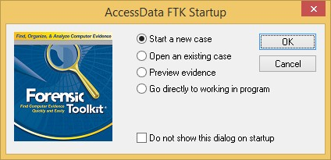
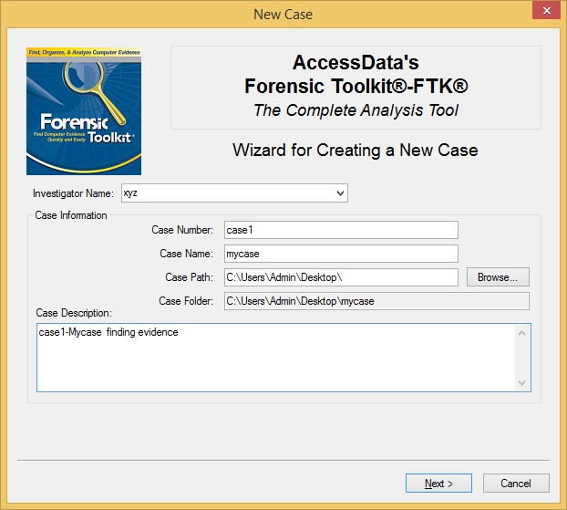

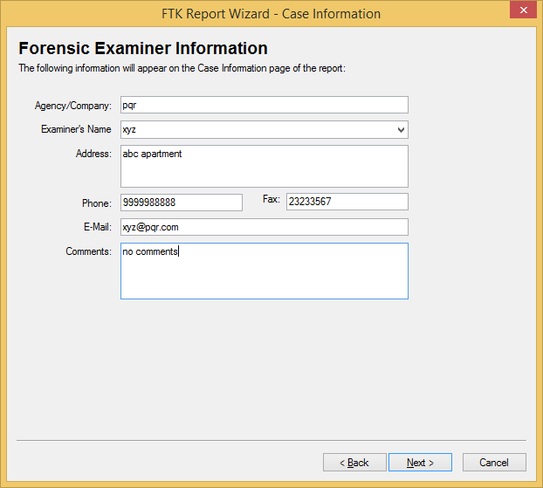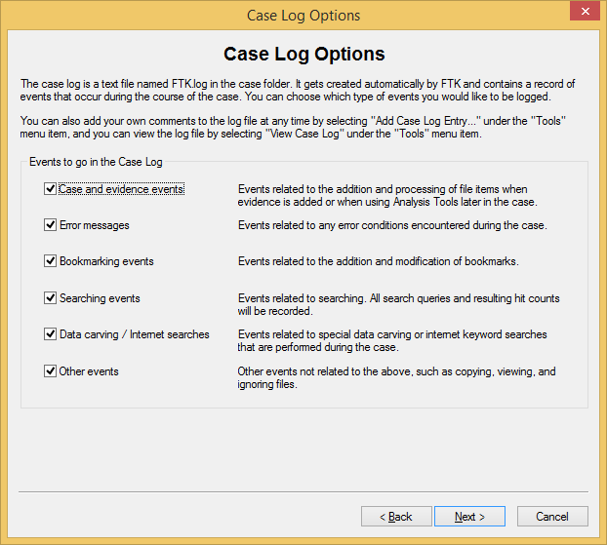
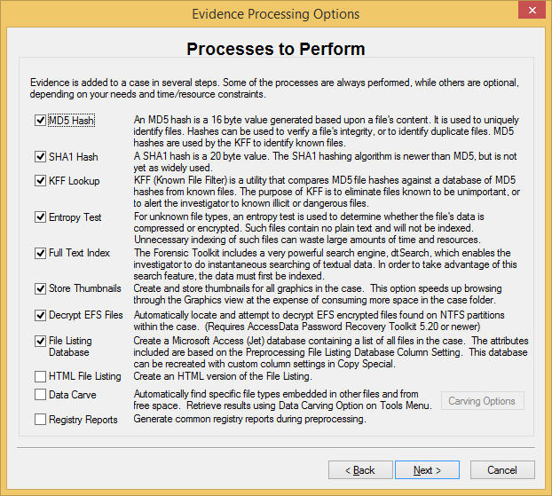
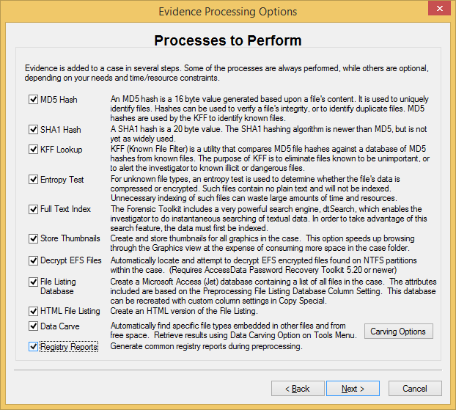
select include all items
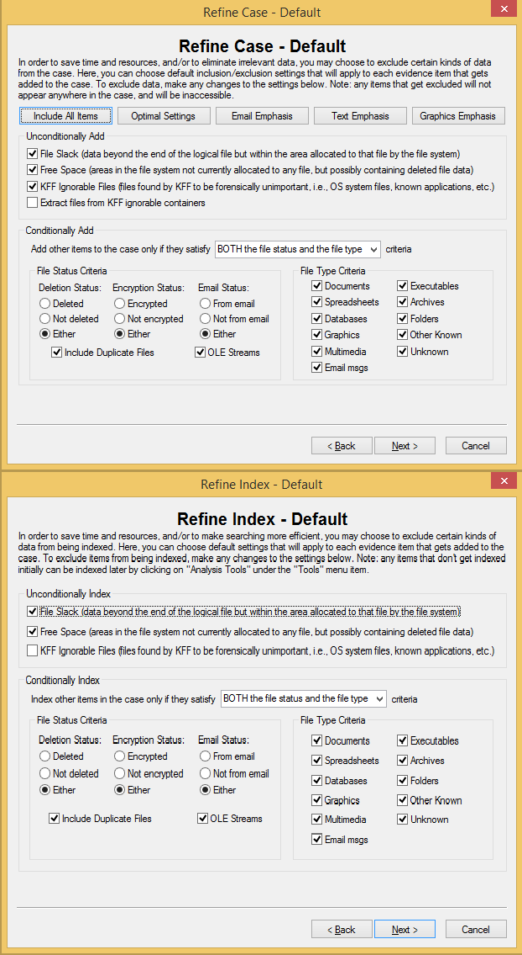
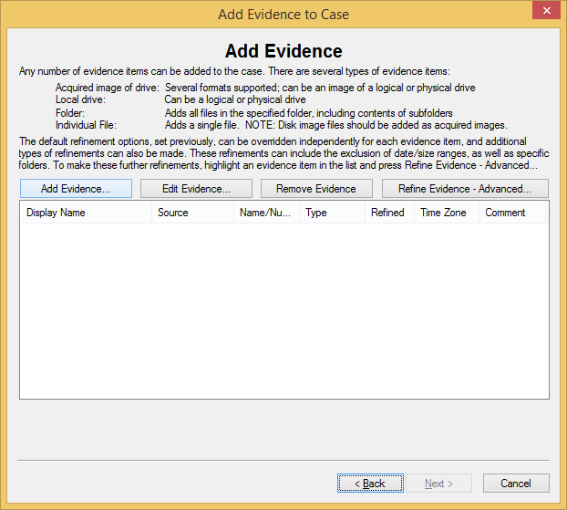

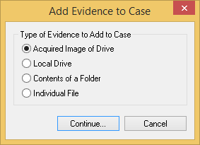
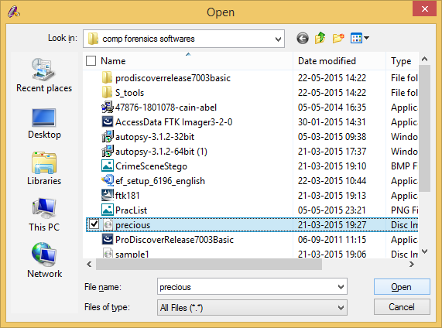
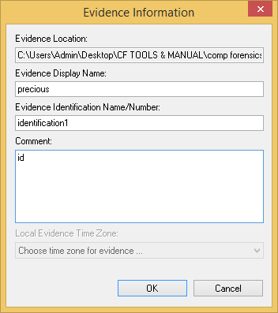
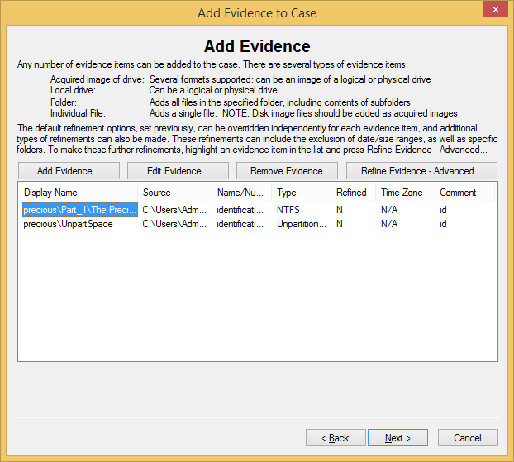
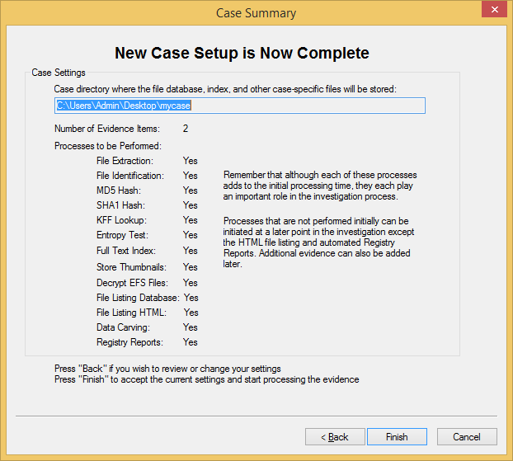
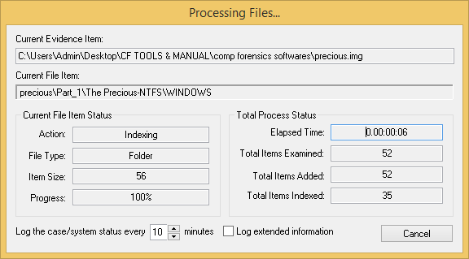
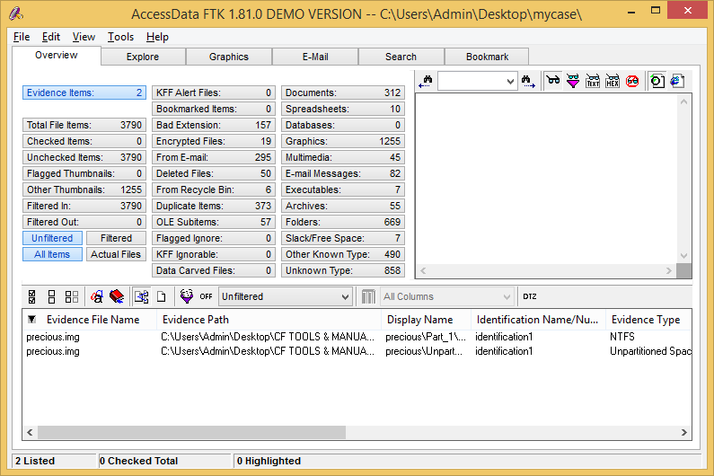
after processing is finished the results are shown as above.
Evidence and File Items
The statistics for each category are automatically listed. Click the category button to its associated file list.

Category | Description
Actual Files | Filters out parsed files and lists only actual files in the case. An actual file is one that existed on the original hard drive as a file: documents,  zip files, executables, logs, etc.  For example, a file extracted from a Zip archive is filtered out.
All Items | All items in the case. This includes files as well as embedded items such as e-mail attachments, files within Zip archives, and so forth.
Checked Items | All items that are checked in any of the FTK windows.
Evidence Item | A physical drive, a logical drive or partition, or drive space no included in any  partitioned virtual drive.
File Item | Individual items added to the case such as text files, documents graphics, OLE  items, drive images, and so forth.
Filtered Filters the items shown in the Overview window.

Filtered In | Files included by the current filter.
Filtered Out | Files excluded by the current filter.
Flagged Thumbnails | Graphics you have flagged. Flagged graphics appear with a green button in the thumbnail view in the Graphics window.
Other Thumbnails | Graphics that have not been flagged. These graphics appear with a red button in the thumbnail view in the Graphics window.

Total File Items Total items in the case, which is not necessarily the number of files in the case because multiple items can be parsed out of one file. For
example, a Zip archive can contain many items.
Total File Items is the total items in the case unless Filtered is selected.
Category | Description
Unchecked Items | All items that are left unchecked.
Unfiltered | A filter that overrides normal filters. This filter is specific to the  Overview window.
File Status | File Status covers a number of file categories that can alert you to problem files or help you narrow down a search.  The statistics for each category are automatically listed. Click the category button to the file list associated with it.

Category | Description
KFF Alert Files | Files identified by the HashKeeper Website as contraband or illicit
 | files.
KFF Ignorable | Files identified by the HashKeeper and NIST databases as common,
 | known files such as program files.
OLE Subitems | Items or pieces of information that are embedded in a file, such as
 | text, graphics, or an entire file. This includes file summary
 | information (also known as metadata) included in documents,
 | spreadsheets, and presentations.
File Category
 | File Category itemizes the files by function, for example, a
 | word processing document, graphics, e-mail, executable
 | (program file), or folder.
 | The statistics for each category are automatically listed. Click
 | the category button to the file list associated with it.
Category | Description
Archives | Archive files include e-mail archive files, Zip, Stuffit,Thumbs.db
 | thumbnail graphics, and other archive formats.
Databases | Includes databases from Access, Quicken, Microsoft Money,
 | QuickBooks, and others.
Documents | Includes most word processing, HTML, WML, HDML, or text files.

Category | Description
E-mail Message | Includes e-mail messages from Outlook, Outlook Express, AOL,
 | Netscape, Yahoo, Earthlink, Eudora, Hotmail, and MSN.
Executables | Includes executables from Win32 executables and DLLs, OS/2,
 | Windows VxD, Windows NT, JavaScript, and other executable
 | formats.
Folders | Folders or directories that are located in the evidence.
Graphics | Includes the standard graphic formats like .tif, .gif, .jpeg, and .bmp.

Multimedia | Includes the multimedia formats such as: MP3, Flash, QuickTime,
 | WAV, and MIDI.
 | Important: This feature may not place every multimedia type, including
 | supported types, in the Multimedia container. You should still search for
 | any known multimedia types.
Other Known Type | A miscellaneous category that includes audio files, help files,
 | dictionaries, clipboard files, link files, etc.
Slack/Free Space | Fragments of files that have not been completely overwritten.
Spreadsheets | Includes spreadsheets from Lotus, Microsoft Excel, Quattro Pro, and
 | others.
Unknown Type | File types that FTK cannot identify.

Explore Window
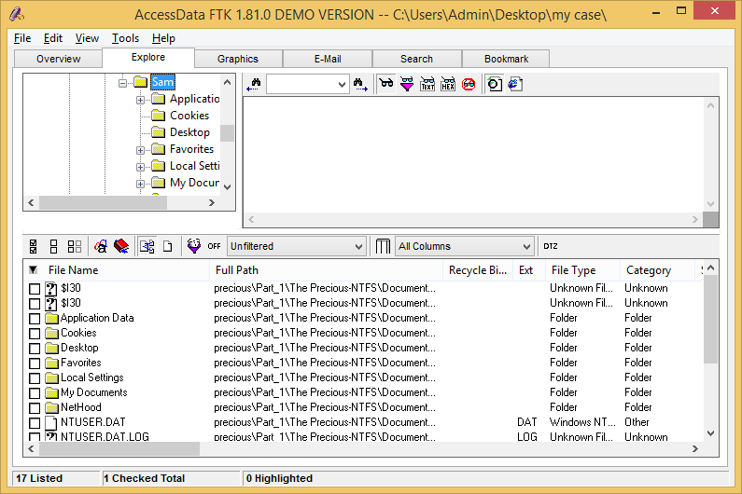

The Explore window displays all the contents of the case files and drives.

The Explore window contains the following:
Tree view: Lists directory structure of each evidence item, similar to the way one would view directory structure in Windows Explorer. An evidence item is a physical drive, a logical drive or partition, or drive space not included in any partitioned virtual drive. The List All Descendants option on the Tree View toolbar displays all the currently selected folder’s files in the File List.
Viewer: Displays the contents of the currently selected file. The Viewer toolbar allows you to choose different view formats.
File List: Displays information about a file, such as filename, file path, and file type.

Graphics Window
The Graphics window displays the case in photo-album style. Each graphic file is shown in a thumbnail view. If you select a graphic, it is displayed in the viewer.
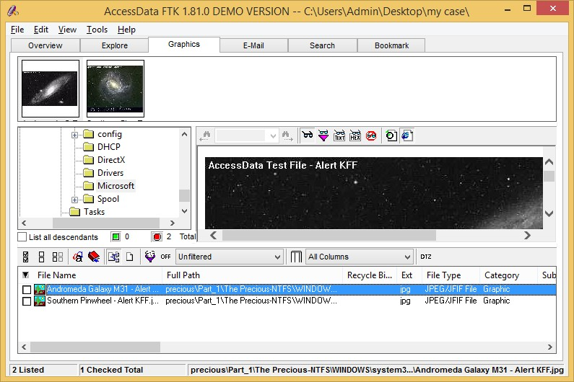
Beneath each thumbnail image is a button that can be clicked red or green. Flagging a graphic red or green is only relevant to the case report. When creating a report, you can choose to include all of the graphics in the case or only those graphics that are flagged green. To automatically mark all the thumbnails green, click the green button in the Tree View toolbar. Conversely, click the red button in the Tree View toolbar to automatically mark all the thumbnails red.
In the Graphics window, only graphic files appear in the File List. This simplifies the process of working with graphics.
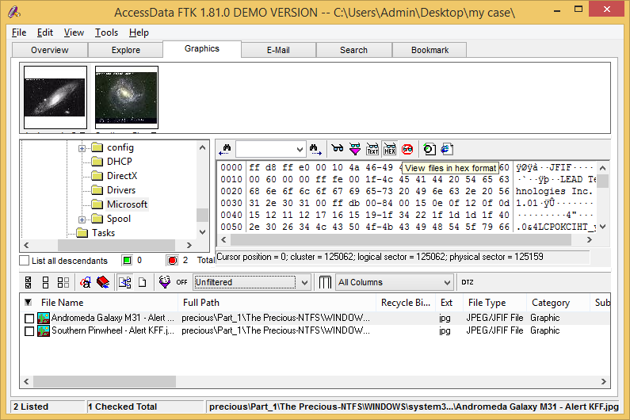

You can view the image in Hex format also E-mail Window
The E-mail window displays e-mail mailboxes, including Web e-mail, and their associated messages and attachments. The display is a coded HTML format.
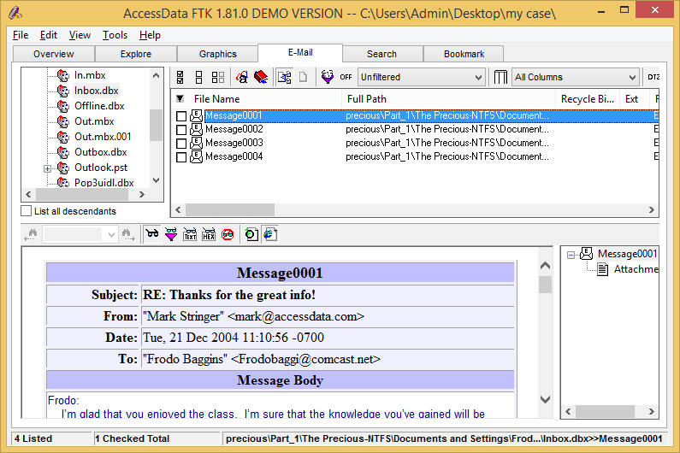
View e mails in different viewers
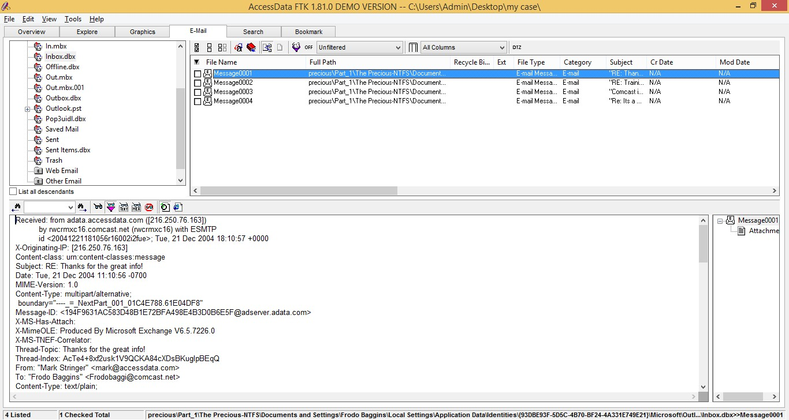
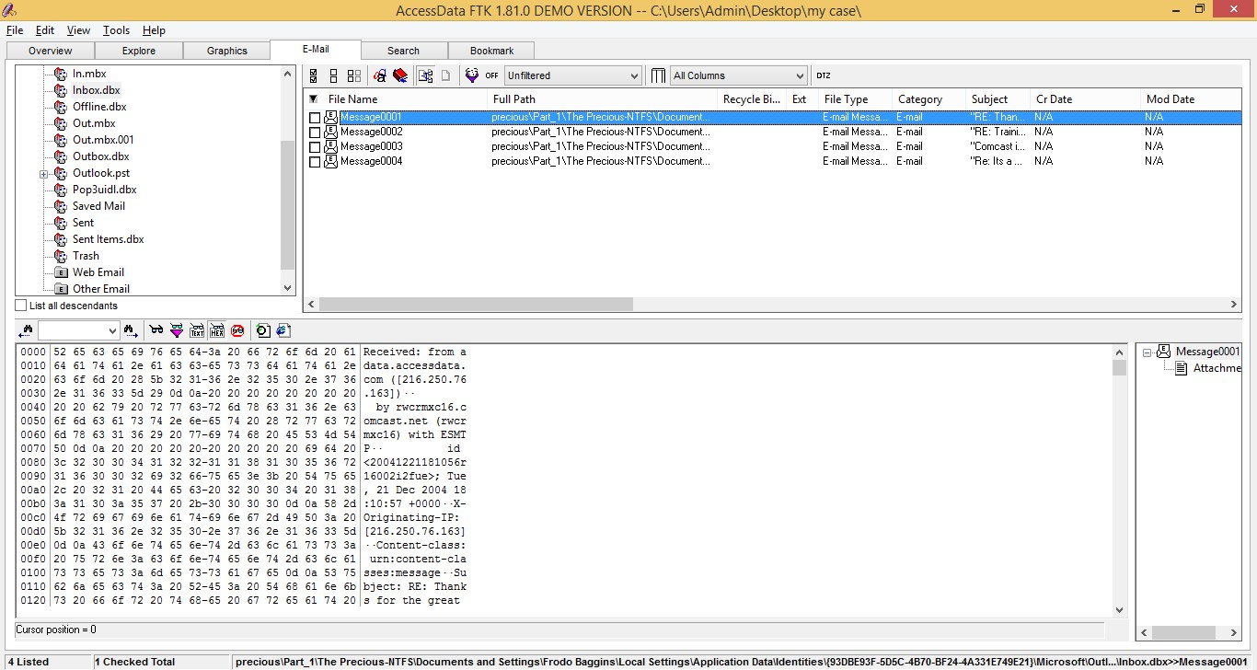

Search Window

Through the Search window, you can conduct an indexed search or a live search. An indexed search is fast. A live search is more flexible.
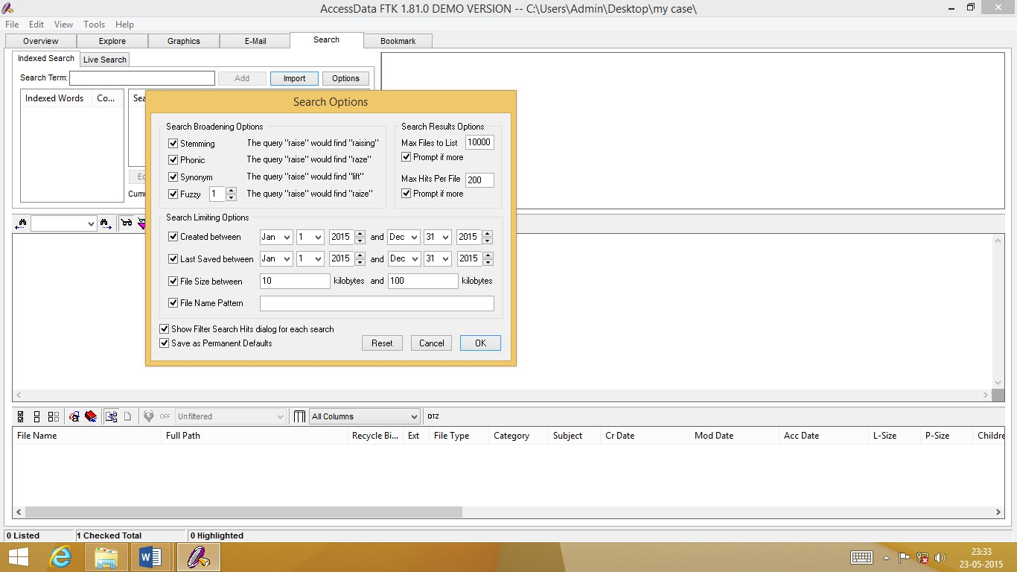

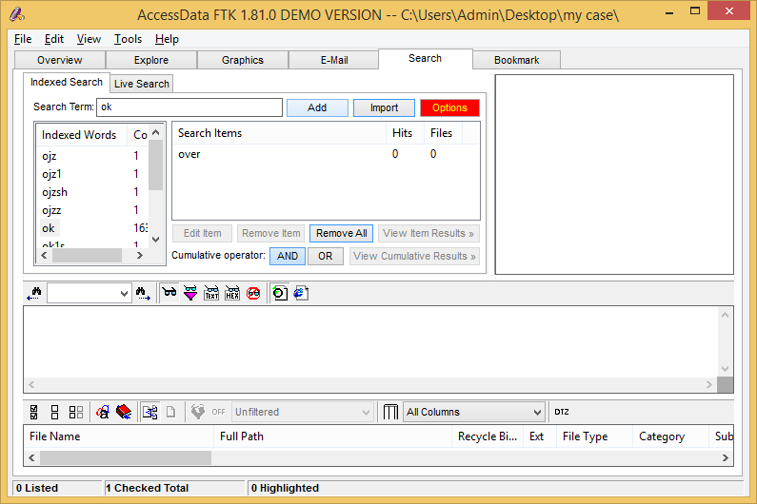
You can add search items by typing words in search terms and click add to add in search items
In a live search tab type name in the search box and click add and then click search
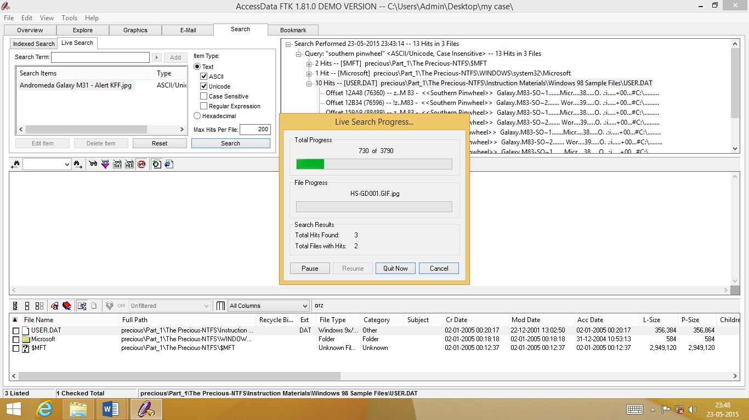
Indexed Search

 | The following table describes the interface options on the
 | Indexed Search tab.
Interface Option | Description
Add | Adds the search term to Search Items. You can add multiple terms to
 | one search.
Count | The number of times the indexed word is found in the case.
Cumulative Operator: | This operator is specific to multi-term searches. FTK looks for items
And | that contain all the search terms listed in the search list.
Cumulative Operator: | This operator is specific to multi-term searches. FTK looks for items
Or | that contain any of the search terms listed in the search list.
Edit Item | Allows you to edit the currently selected search term.
Files | The number of files the search term is found in.
Hits | The number of times the search term is found in the case.
Import | Imports search terms from text files.
Indexed Words | This column displays the index. When a search term is entered in the
 | search field, this column scrolls to display the term in the index.
Options | Options that allow you to broaden or narrow the search.
Remove All | Removes all search terms from the search list.
Remove Item | Removes the currently selected search term from the search list.
Search Items | Lists the search terms.

Search Term field | The field in which you enter the term you want to search for.
View Cumulative Results | Initiates a multi-term search.
View Item Results | Initiates a single term search.

Live Search

The following table describes the interface options on the Live Search tab.

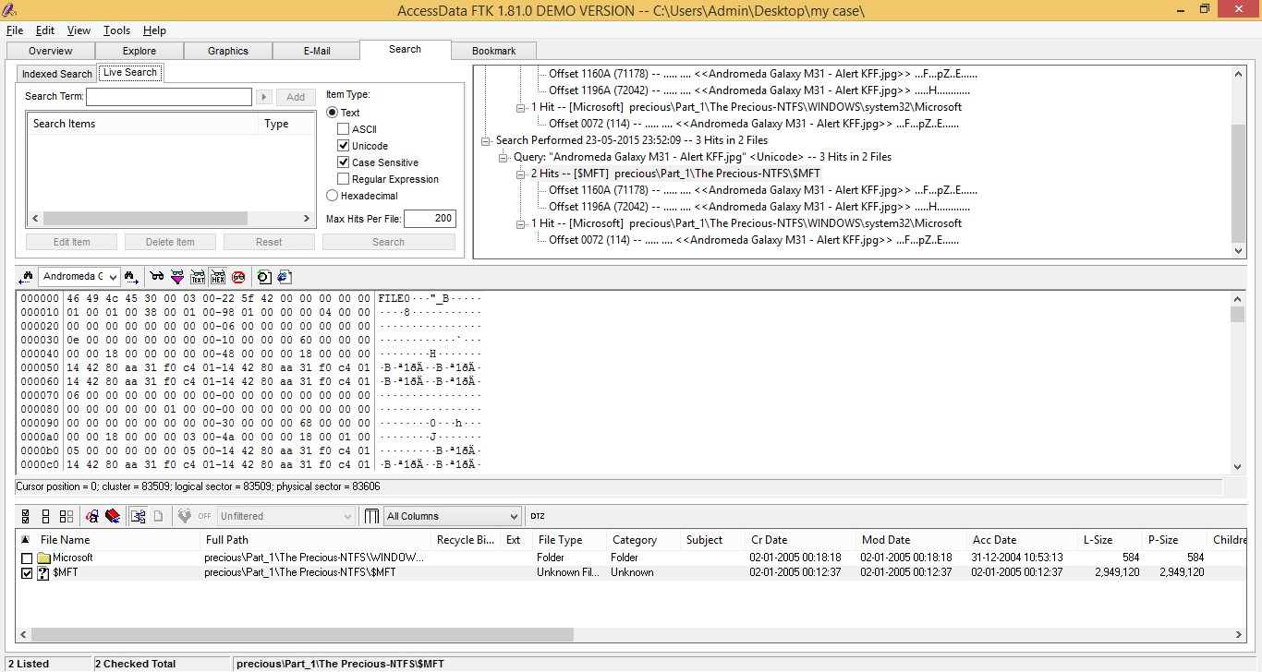

Interface Option | Description
Add | Adds the search term to the search list. You can add multiple terms
 | to one search.
ASCII | Searches any text in the same single-byte character set that your
 | Windows version natively uses.
 | For example, the English version of Windows uses the ISO 8859-1
 | character set; therefore, on English systems, you can find words in
 | any ISO 8859-1 language.
 | Note: For a listing of character sets used by common languages, visit
 | http://www.w3.org/International/O-charset-lang.html.
Case Sensitive | Searches for the term exactly as it is typed in the Search Term field.
Delete Item | Deletes the currently selected search term from the search list.
Edit Item | Allows you to edit the currently selected search term.

Interface Option | Description
Hexadecimal | Searches in hexadecimal. It can be used to find embedded
 | information that doesn’t display in text.
Max Hits Per File | Lists the maximum number of search hits that will be returned in a
 | search.
Regular Expression | Searches patterns in files, such as, any numbers that are in a phone
 | number pattern.
 | When selected, the arrow next to the Search Term field is activated.
 | Clicking the arrow displays the predefined regular expressions and
 | the option to edit the expressions.
Reset | Clears all search terms from the search list.
Search | Searches all files or filtered files (depending on what you select) for
 | the terms listed in Search Items.
Search Items | Lists the search terms.
Search Term field | The field in which you enter the term you want to search for.
Text | Searches text.
Type | Lists what was selected under Item Type.
Unicode | Converts the ASCII/ISO 8859-1 text typed in the Search Term field
 | to Unicode (the UCS-2 little endian form) and searches the Unicode
 | version of the text.
 | This search cannot be used to find Unicode text, because there is
 | no way to type Unicode text in the Search Term field. So, while
 | the Unicode search doesn't search any additional languages, it does
 | let you find ASCII/ISO 8859-1 strings that are being stored in
 | Unicode.

Bookmark Window
On the Bookmark window, you can view all the items you have bookmarked as important items in the case. You can also add comments and mark them for inclusion in the report. For
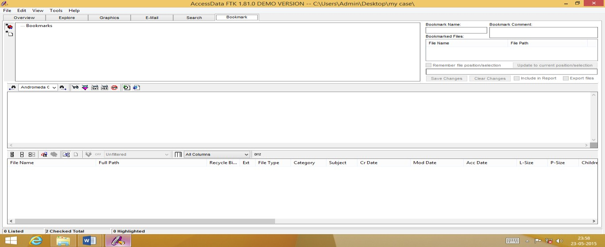

The following table describes the interface options specific to
 | the Bookmark window.
Interface Option | Description
Bookmark Comment | Displays comments included with a bookmark.
Bookmark Name | Displays the name given to a bookmark when it was created.
Bookmarked Files | Number of bookmarked files.
Clear Changes | Resets the Include in Report and Export Files settings in the current
 | bookmark.
Export Files | If checked, the files included in the bookmark are exported when a
 | report is generated.
File Path | Displays the paths of bookmarked files.
Filename | Displays the bookmarked files’ filenames.
Include in Report | If checked, includes the bookmark and its files in case reports.

Interface Option | Description
Remember File | Remembers the highlighted text in the first bookmarked file and
Position/Selection | automatically highlights it when you return to the bookmark. The
 | highlighted text also prints in the report.
 | This option is disabled if there is more than one file in the bookmark.
Save Changes | Saves the Include in Report and Export Files settings for the current
 | bookmark.
Update to Current | Use this option to change which text is highlighted in the
Position/Selection | bookmarked file.
 | To change which text is highlighted in the bookmarked file:
 | 1. Select the text you want highlighted when you return to the bookmark.
 | 2. Click Update to Current Position/Selection.
 | This option is disabled if there is more than one file in the bookmark.

Backing Up the Case

You can back up your case at any time during your evidence processing. In addition, you will be asked to back up the case before exiting FTK.
To back up the case manually, click File, and then Backup Case and then select an empty directory where you want the backup to be created. Subsequent backups will be made to this directory unless another directory is specified.

Storing Your Case Files
Storing your case file and evidence on the same drive substantially taxes you processors’ throughput. Your system slows as it saves and reads huge files. For desktop systems in laboratories, you can increase your processors’ speed by saving evidence files to a separate server.
If you are taking the case out of the lab, you may choose to compromise some processor speed for the convenience of having your evidence and case on the same drive.

Recovering Evidence from a System Failure
Processed data from which you gather evidence is saved in the DefaultCase folder. This folder is intended to be temporary, and will be erased each time you start an FTK session. You must save data you are processing to a named case folder to avoid being erased each time you start the program.
Do not process evidence without starting a case to which you can save it. If you have processed evidence outside of a case, and FTK closes before you save it, you will be prompted to save the evidence to a file.
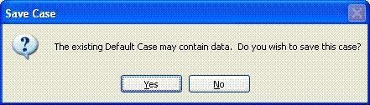
Click Yes to open the Case Information dialog, and name the data you want to save.
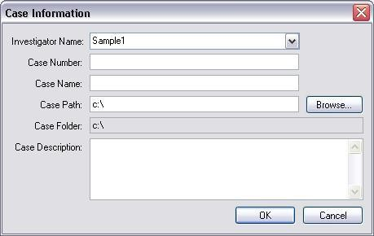
Click No to exit FTK. The data will be deleted.

Backing Up Cases Automatically
The FTK program can automatically backup a case following preprocessing. The backup is saved in a directory named after the case that’s running, but with “_bak” appended to the case name. For example, if
you were processing a case saved on c:\casefiles\case1\etc., your automatic backup would be created in the directory c:\casefiles\case1_bak\etc.
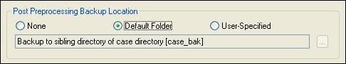

The automatic backup feature creates backups for the case on which you’re currently working. To speed up the copying process, the backup does not include the Thmbldx directory.
A successful backup will complete without any notice other than a log entry. If the automatic backup fails, a message box will pop up notifying you, and details of the failure will be entered in the case log.

Opening an Existing Case
You can open an existing case from FTK or from the command line. To open an existing case from FTK:
- In Forensic Toolkit (FTK), select File, and then Open Case.
Or if you have chosen to always display the FTK Startup screen, select Open an Existing Case and click OK.
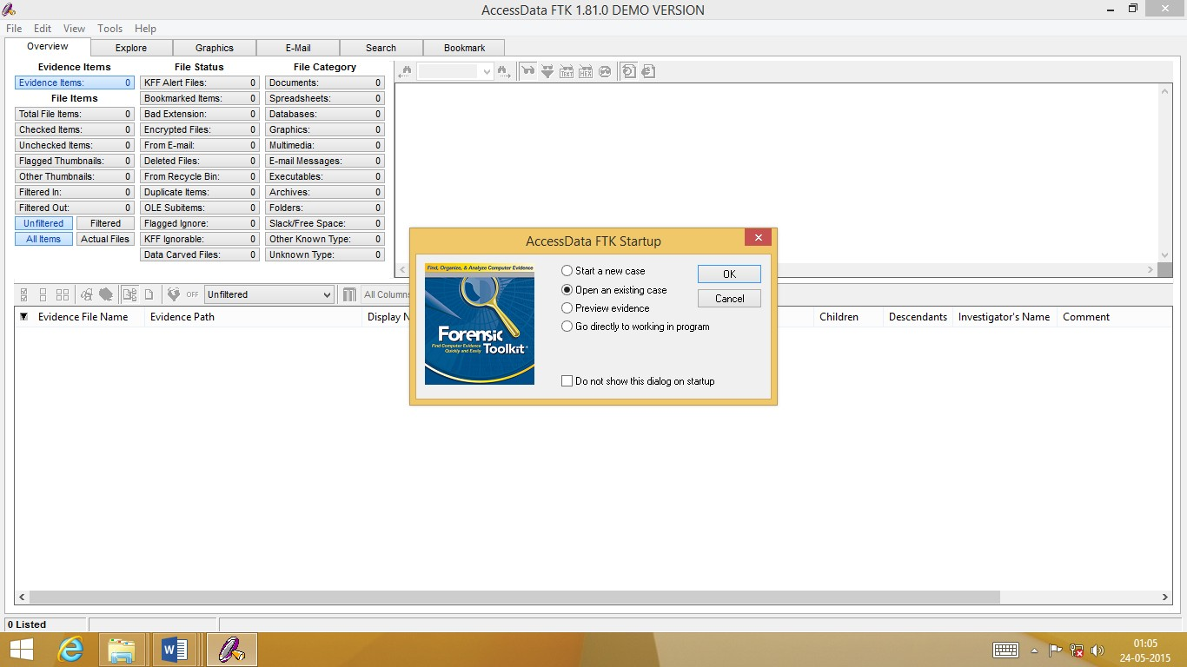

- Select the case you want to open.
Remember, all case files are named case.ftk. The case.ftk file for each case is stored in the applicable case folder.
To open an existing case from the command line, type the following command at the command line:
path_to_ftk_program_file\ftk.exe /OpenCase target_case_directory

Opening an Existing Case from a Different Location
If you have processed a case, then move the files to another location, FTK will prompt you to redirect the program to the new path.

Important: Do not add the processed evidence to FTK; the program will reprocess the data.
To open an existing case from a different location:
- Start the FTK program, and select Open an Existing Case. The FTK program will not find the case data in the old location, and will prompt you to browse to the new location.

- Click OK to browse to the new location, and then choose the case file. The FTK program will prompt you to make this new path the permanent path for this case.
- Click Yes. The FTK program will automatically open the case from that location.
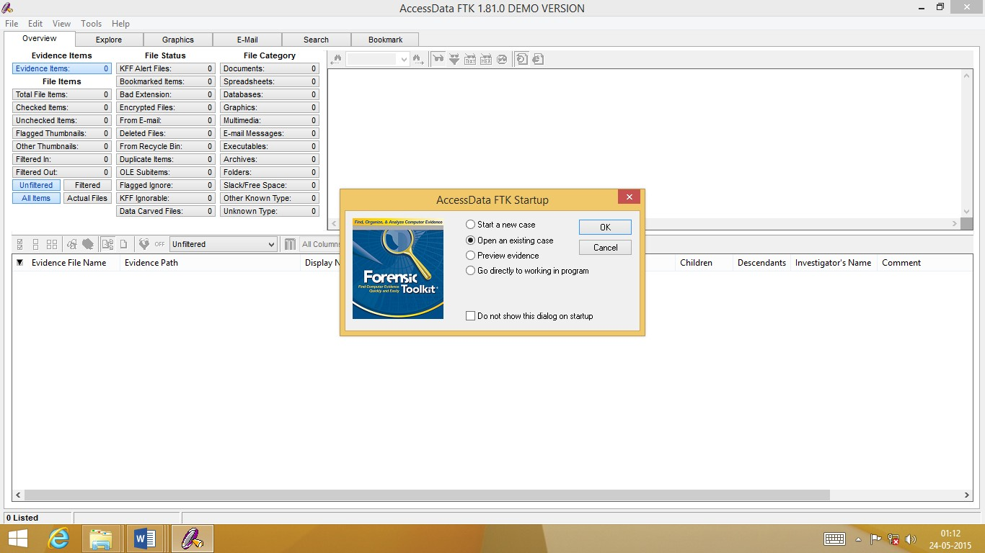
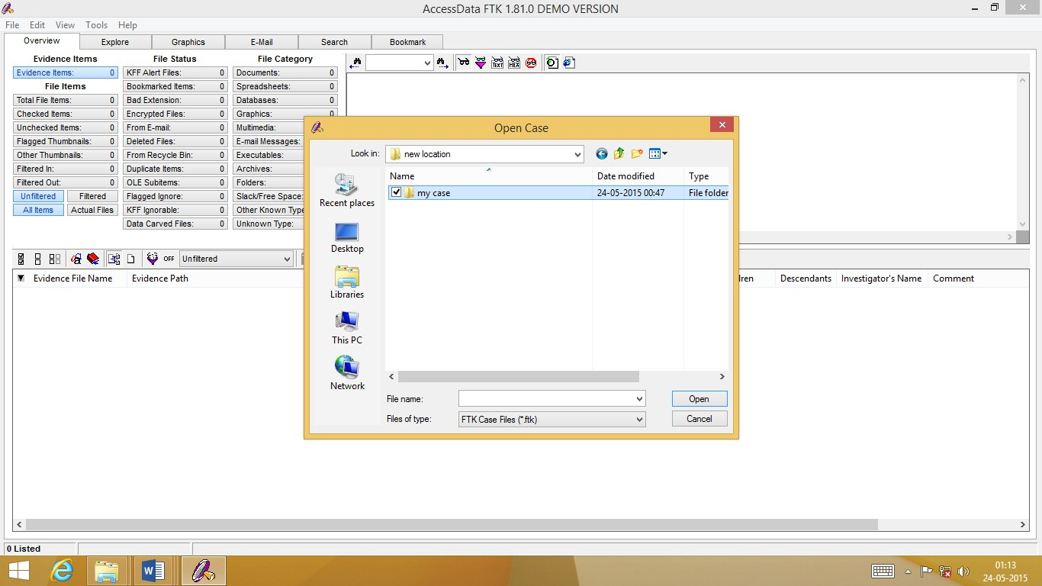
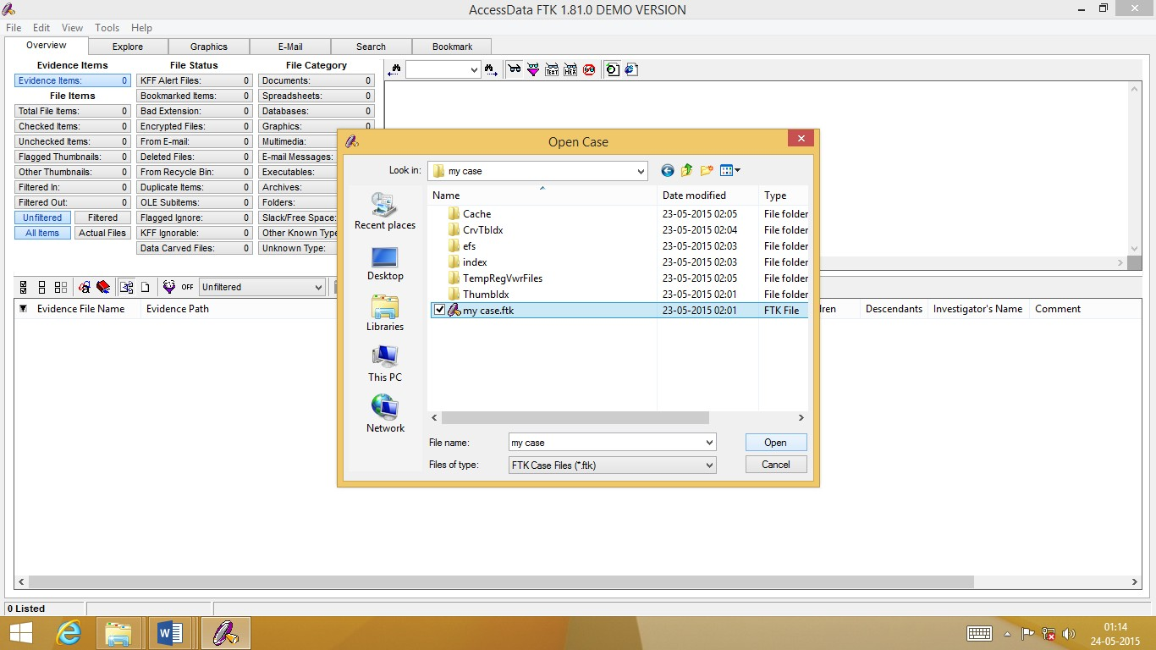
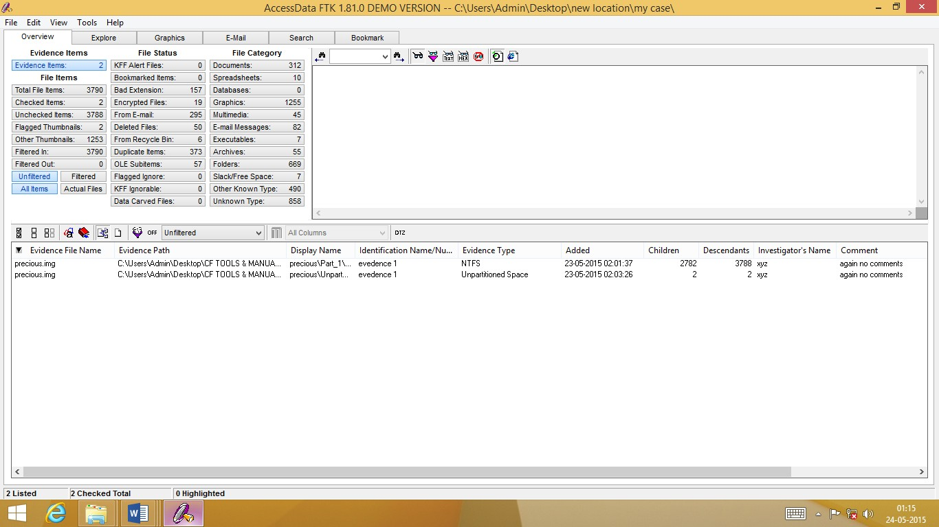

Opening a Case in Case Agent Mode (Read-only)
You can open a case in Read-only mode so that evidence cannot be added or deleted. This is called Case Agent Mode. When FTK is in Case Agent Mode, the following occurs:
No evidence can be added to the case.
No items flagged with Ignore Status are displayed, including items within bookmarks. The Flagged Ignore container is always empty.
The evidence item numbers displayed in the Overview window may not reflect the available files because files flagged with an Ignore Status are not displayed.
The Ignore Status flag cannot be removed. A new case cannot be created from this case. The live search does not show files flagged with the Ignore Status.
Index Search results does not display hits in files flagged with the Ignore Status.
Note: The hit count displays the total hits; however the Results window does not display hits in ignored files. Therefore the number of hits in the Results window may be different than the total number of hits reported when you enter the search term.
To open FTK in Case Agent Mode, type the following command:
path_to_ftk_program_file\ftk.exe /CaseAgent
If you want to open a specific case in Case Agent Mode, type the following command:
path_to_ftk_program_file\ftk.exe /CaseAgent /OpenCase
target_case_directory
Note: The default location for the FTK program is C:\Program\Files\AccessData\AccessData Forensic Toolkit\Program\ftk.exe.

Using the Case Agent Mode Manager
Case Agent Mode Manager has been enhanced to give forensic examiners more control over the FTK features that will be

available to forensic investigators for a given FTK case. This feature set is configured by the forensic examiner in the Case Mode Manager.
Case Agent Mode Manager has the following features:
Password Protection: Case Agent Mode Manager is password-protected so that forensic examiners can control what FTK features forensic investigators have access to. If you administer FTK, you have the password needed to set these settings. If you are a forensic investigator using FTK, Case Agent Mode Manager has been customized for your work environment and it is unnecessary for you to access this tool.
To set Case Agent settings:
- Start FTK in Case Agent Mode.
- Select Tools, and then Case Agent Mode Manager.

- From the Features tab, select the FTK tools that will be available when FTK is in Case Agent Mode.
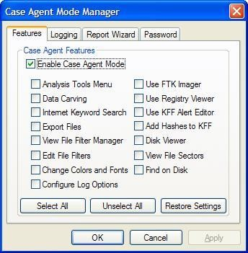
- From the Logging tab, select the events to include in the case log when FTK is in Case Agent Mode.

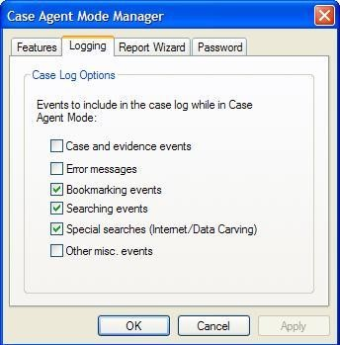

- From the Report Wizard tab, select what Report Wizard options will be available to the investigator when FTK is in Case Agent Mode.
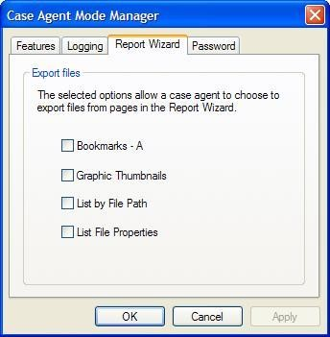
- From the Password tab, set the password for the Case Agent Mode Manager. When you start Case Agent Mode Manager the next time, this is the password that will be used.

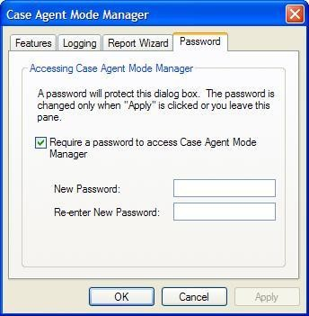
- Click Apply

Adding Evidence
During the case investigation, you might need to add a file, folder, drive, or image to a case. FTK uses the Add Evidence Wizard to add evidence to a case.

  - Open the case to which you want to add evidence. Click File, and then Open. Select the case.ftk file for the appropriate case.
  - Click File, and then Add Evidence. The Add Evidence Wizard opens.
  - Enter the investigator’s name.
  - Check the processes that you want run on the evidence.
  - Add the evidence.
  - Review your evidence selections.
  - Complete the wizard to launch the processing of evidence

Completing the Add Evidence Form
The Add Evidence form provides information about the case investigator and other case basics. The Case Information and Description fields contain the data that you entered when you created the case. The only field you can modify in this wizard is the investigator’s name
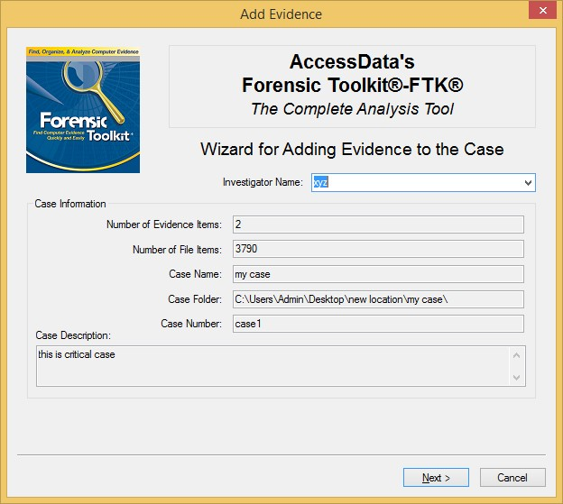

Selecting Evidence Processes
The Evidence Processing Options form allows you to specify how you want the evidence processed. These
processes can shape the scope of your analysis and the outcome of your case.
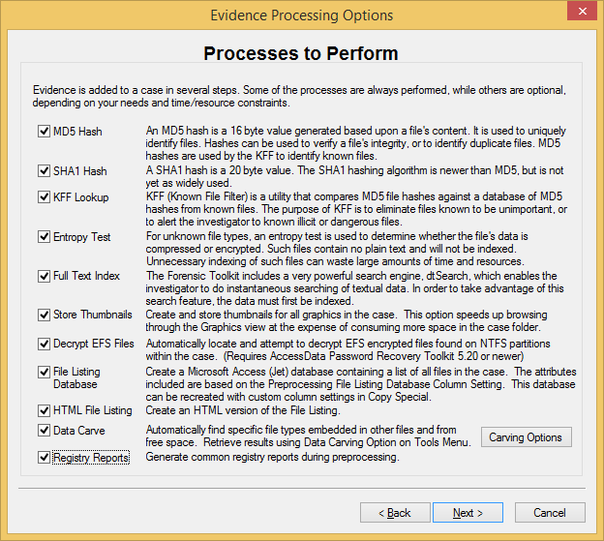
In the Evidence Processing Options form:
- Select the processes that you want to be run on the evidence.
- Click Next.

Managing Evidence
The Add Evidence form allows you to select the following functions:
Add evidence.
Remove evidence
Edit basic information about the evidence.
Create parameters for adding evidence to the case.

Adding Evidence
Evidence added during the same session of the New Case Wizard is created as part of one complete case. For example, you can add evidence from multiple floppies, a ZIP disk, and a hard drive.

Note: To protect the integrity of case evidence, all items are added as read-only.
You can add the same evidence item to multiple cases. To add evidence to the case:
1 In the Add Evidence to Case form, click Add Evidence

2 | Select one of the following evidence types and click
 | Continue:
Evidence Type | Description
Acquired Image of Drive | A forensic image of a logical or physical drive.
 | If the image is segmented, select the first segment.
 | Important: All the image segments must be placed in a single directory
 | for FTK to process them properly.
Contents of a Folder | A specific folder, any accompanying sub-folders, and files.
 | The contents of a folder are always added in logical form; that is, they
 | do not include file slack or deleted files.
Individual File | A specific file.
 | Individual files are always added in a logical form; that is, they do not
 | include file slack.
 | Note: If you export an encrypted file for decryption, you can use this
 | option to add the decrypted file back to the case.
Local Drive | A logical or physical drive.
 | If you are running FTK on Windows NT, 2000, or XP, make sure that
 | you are logged in on an account with administrative rights.

- Browse to and select the evidence. If you add an unidentified evidence item that is larger
than 25 MB, it will be chunked into 25 MB pieces.
- In the Evidence Information form, enter the following information and click OK:

Editing Case Evidence
The Edit Evidence option allows you to modify the information you entered in the Evidence Information form.
To modify the Evidence Information for a particular item:

- Select an evidence item in the File List.

- Click Edit Evidence.
- Modify the information in the Evidence Information form.

- Click OK.

Removing Case Evidence
The Remove Evidence option allows you to remove an evidence item from the File List.

Important: You can remove an item only from the File List in the Add Evidence form. You cannot remove an item after it has been processed.
To remove an evidence item from the File List, click Remove Evidence.

Refining Evidence
The Refine Evidence-Advanced option allows you to exclude specific data from an individual evidence item.
Note: You cannot refine evidence items once they are added to the case. This must be done while adding the item.
AccessData strongly recommends that you include all items when adding evidence to a case.

Important: After data is excluded from an evidence item, you cannot go back and add it to the case. FTK does not allow you to add the same evidence item more than once. If you discover that you need data that was previously excluded, you must create a new case. Consequently, AccessData strongly recommends that you use include all items unless you are absolutely certain that you will not need any of the excluded items.
To refine case evidence:
  - Select the evidence item in the File List.
  - Click Refine Evidence-Advanced.
The Refine Case-Advanced menu is organized into three windows:
Refine Evidence by File Status/Type Refine Evidence by File Date/Size Refine Evidence by File Path
Click the corresponding tab to access each window
- Define the refinements you want for the current evidence item. If you want to reset the menu to the default settings, click

Reset to Defaults.
- Click Next.
The following sections review each window in the Refine Evidence-Advanced menu.

Refining Evidence by File Status/Type
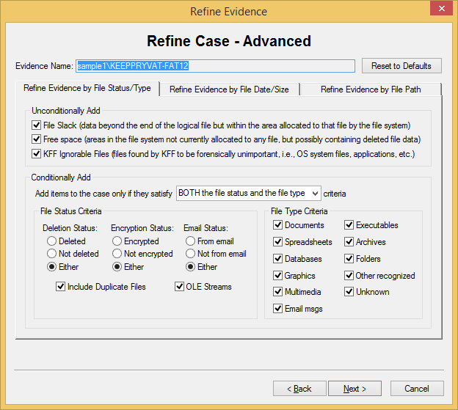

Refining the Index
When you click Next in the Refine Case-Advanced form, FTK brings up the Refine Index-Advanced form.
Note: The Refine Index-Advanced form only appears when you click Next in the Refine Case-Advanced form. It does not appear if you simply click Next in the Add Evidence form.
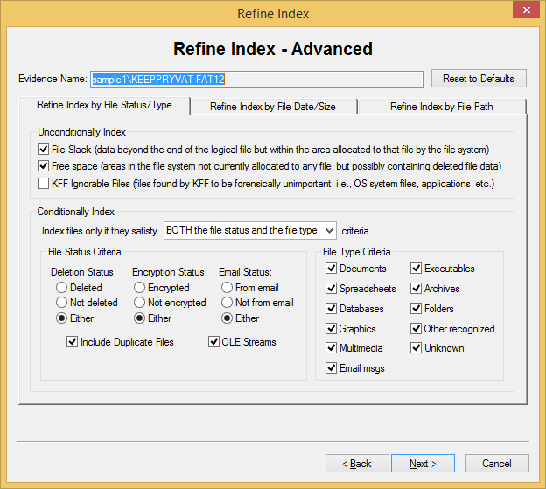

Reviewing Evidence Setup
The Case Summary form allows you to review the number of evidence items and evidence processes that you selected during the Add Evidence Wizard.
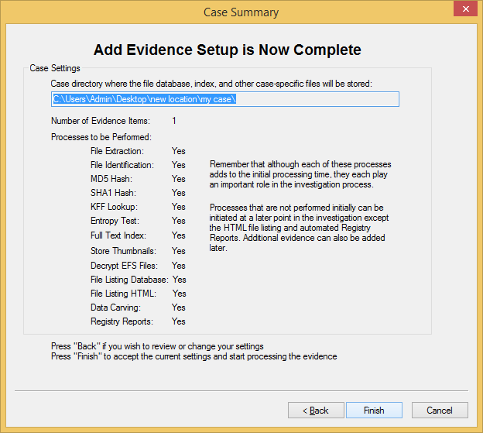
To accept the current settings and start the processing of the evidence, click Finish.

Processing the Evidence
After you click Finish, the Processing Files form appears and displays the status of the processes you selected in the wizard
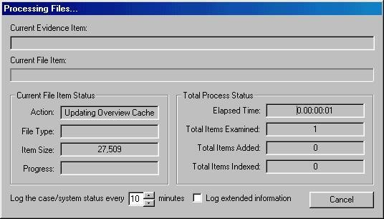

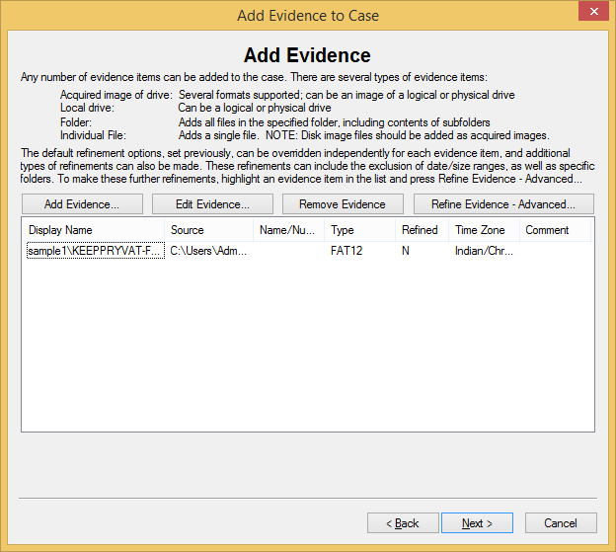

Viewing File Properties
To view a file’s properties:
- Highlight a file in the File List.
- Select Tools, and then File Properties.
The File Properties menu is organized into five information windows: General
File Source File Content Case-specific
E-mail (appears only when viewing file properties for e-mail messages and attachments)
Click on the corresponding tab to access each window. Each window contains the following file information:
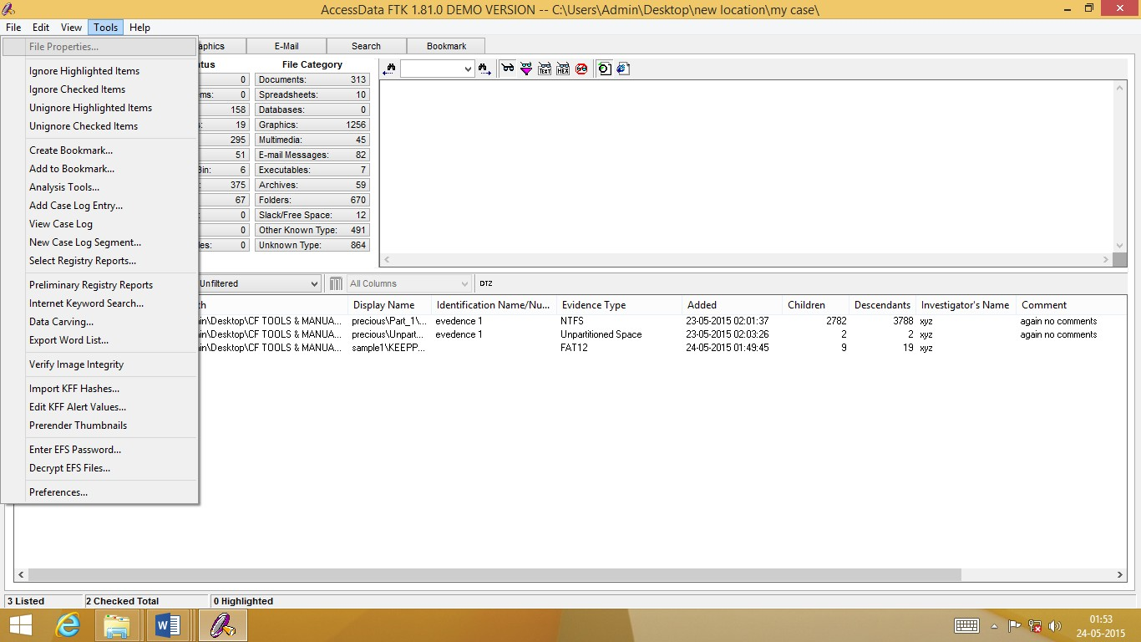

Selecting a file to enable file properties
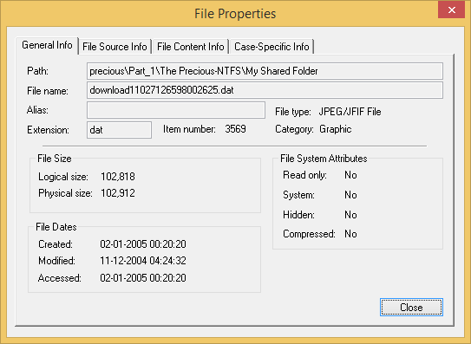

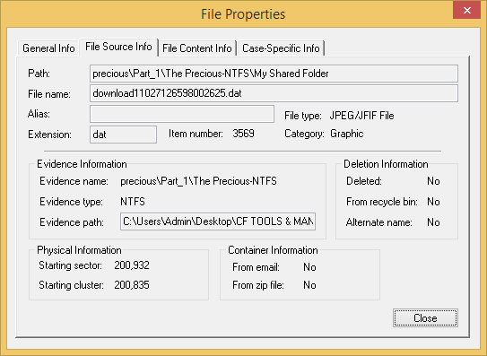
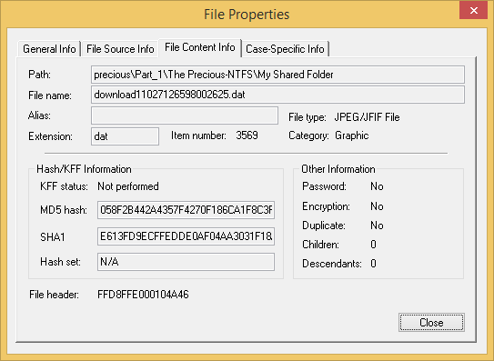
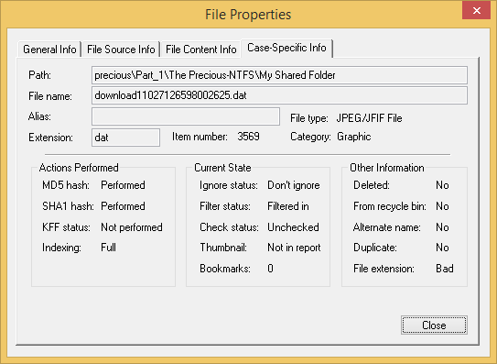

Setting Up Multiple Temporary Files

Click OK
- Click Tools, and then Preferences.
- In the Temporary File Folder area, click the Browse button.
- Click the Folder button, and then select the folder.
The path and folder name appear in the Temporary Files Areas In Order of Use list. Folders are used in the order listed here.
- To change the order of use, select the folder and click the Up or Down arrows to change the order.

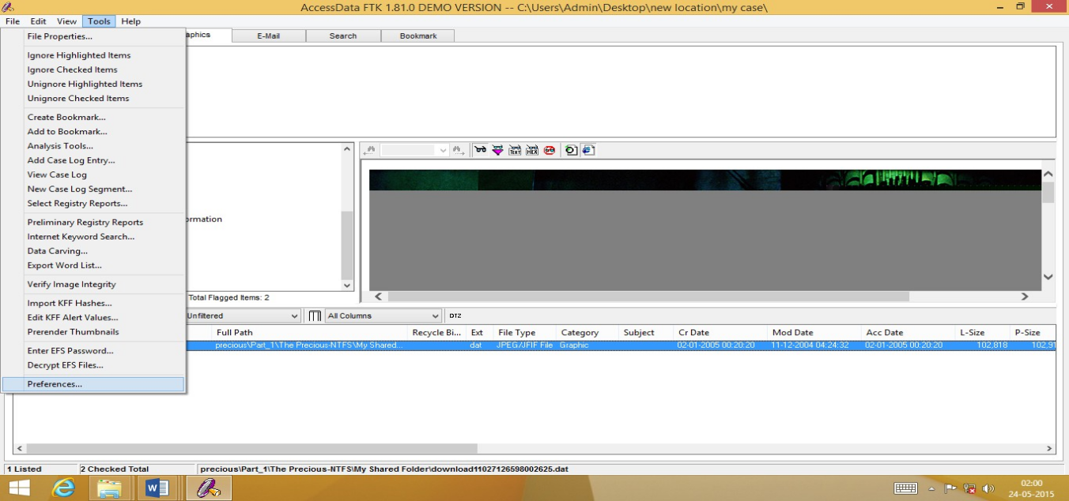

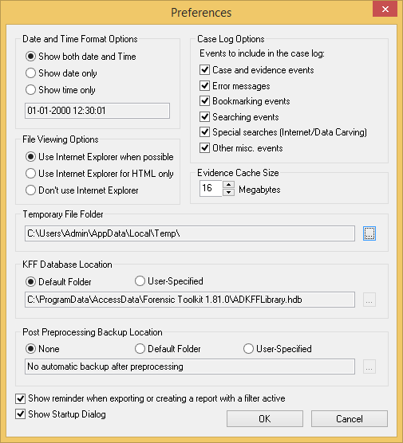
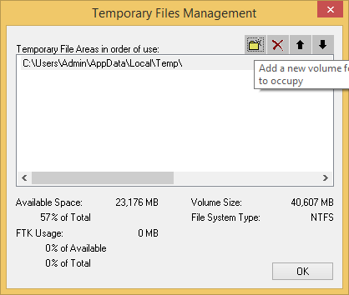
Processing Evidence

Using Bookmarks

A bookmark contains a group of files that you want to reference in your case.
Bookmarks help organize the case evidence by grouping related or similar files. For example, you can create a bookmark of graphics that contain similar images
Creating a Bookmark
To create a bookmark:
  - Select Tools, and then Create Bookmark. The Create New Bookmark form appears.
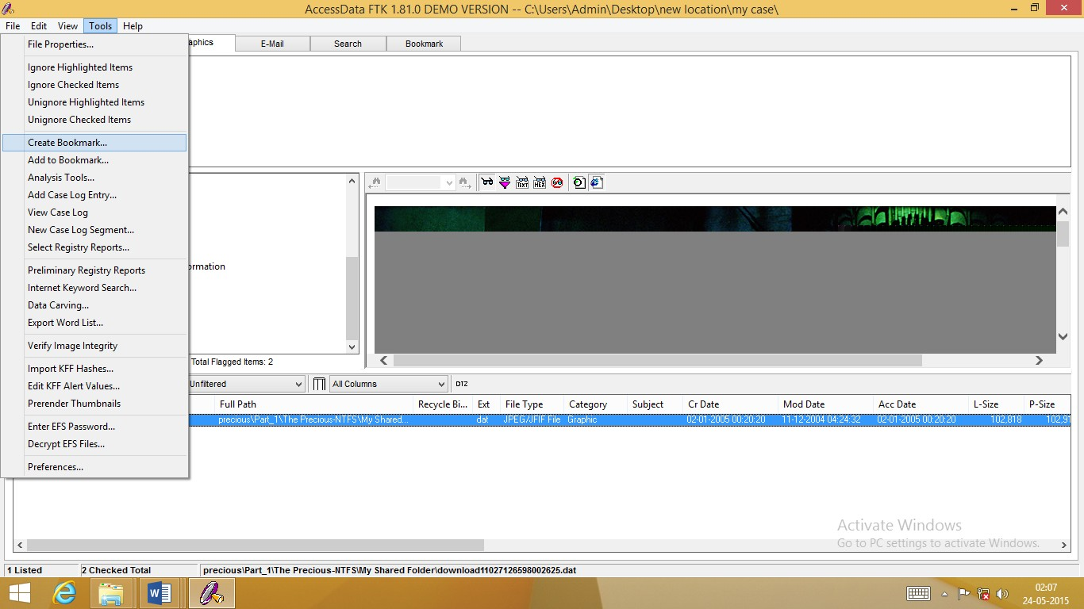
  - In the Bookmark Name field, enter the name of the bookmark. (Optional) In the Bookmark Comment field, enter comments about the bookmark or its contents

4 | Click one of the following to specify which files to add to
 | the bookmark:
Option | Description
All Checked Items | All items checked in all file lists.
 | You can check files in multiple lists.
All Currently Listed | All items in the current file list.
Items
All Highlighted Items | All items highlighted in the current file list.
 | Items remain highlighted only as long as the same window is displayed.

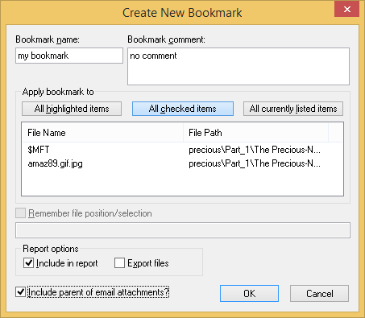

- If you want FTK to remember the highlighted text in the first file and automatically highlight it for you when you return to the bookmark, check Remember File Position/Selection. (The highlighted text will also print in the report.) Note: This option is disabled if there is more than one file in the bookmark.
- Check Include in Report to include the bookmark in the report.
- If you choose to include the bookmark in the report, you can check Export to export the bookmark’s files with the report.
- Click OK.
Adding Files to a Bookmark
To add files to a bookmark:
- In a file list, highlight the file that you want to add to the bookmark. Shift+click to select multiple contiguous files. Ctrl+click to select multiple discontiguous files.
- Right-click and select Add to Bookmark.
The Add Files to Bookmark form appears and displays the filename and full path of the file you selected.
- Do one of the following:
To add to the last-used bookmark, go to Step 4.
For convenience, FTK remembers the last-used bookmark. You can add several files to the bookmark without having to select the bookmark.
To select a different bookmark or select several bookmarks, select the bookmarks to add the file to in the Bookmark Name column.
Shift+click to select multiple contiguous bookmarks. Ctrl+click to select
multiple discontiguous bookmarks.
The Bookmark Comment column displays the comments entered when the bookmark was created.
- Click OK.

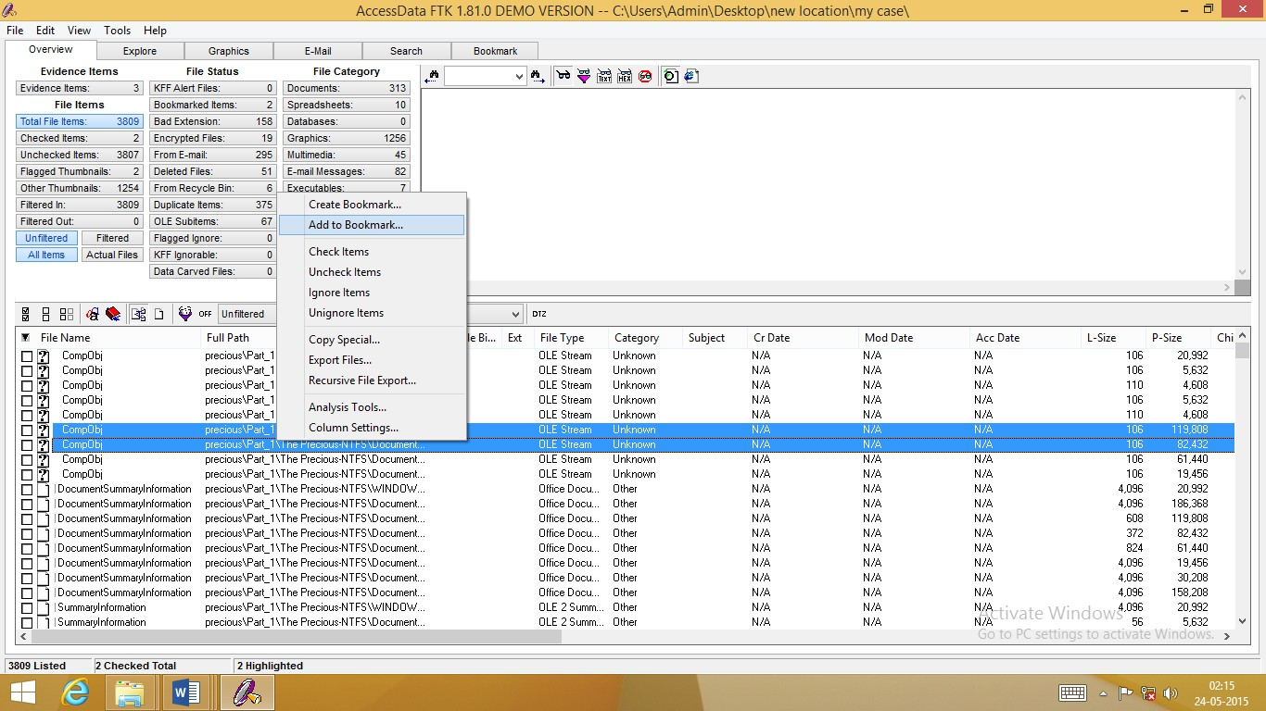
Removing a Bookmark
You can remove both a bookmark and individual files within bookmarks. To remove a bookmark or an individual file:
- In the Bookmark window, expand the bookmark list and highlight the bookmark or file that you want to remove.
- To remove a bookmark, right-click and select Delete Bookmark.
- To remove a file, right-click and select Remove This File From the Bookmark.
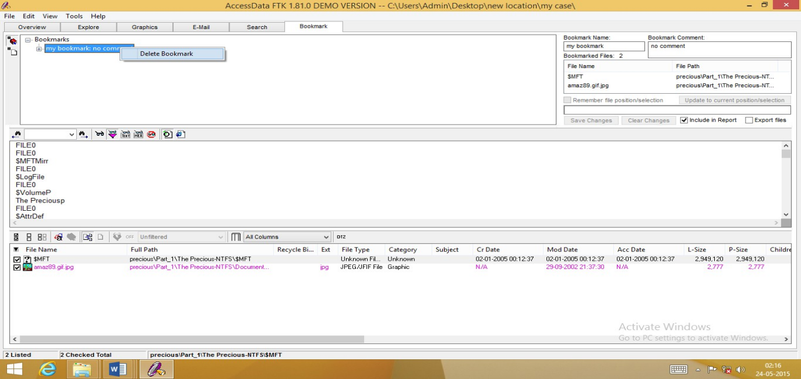

Creating Thumbnails
To create the thumbnails after you have added the graphics to the case, click Tools, and then

Prerender Thumbnails.
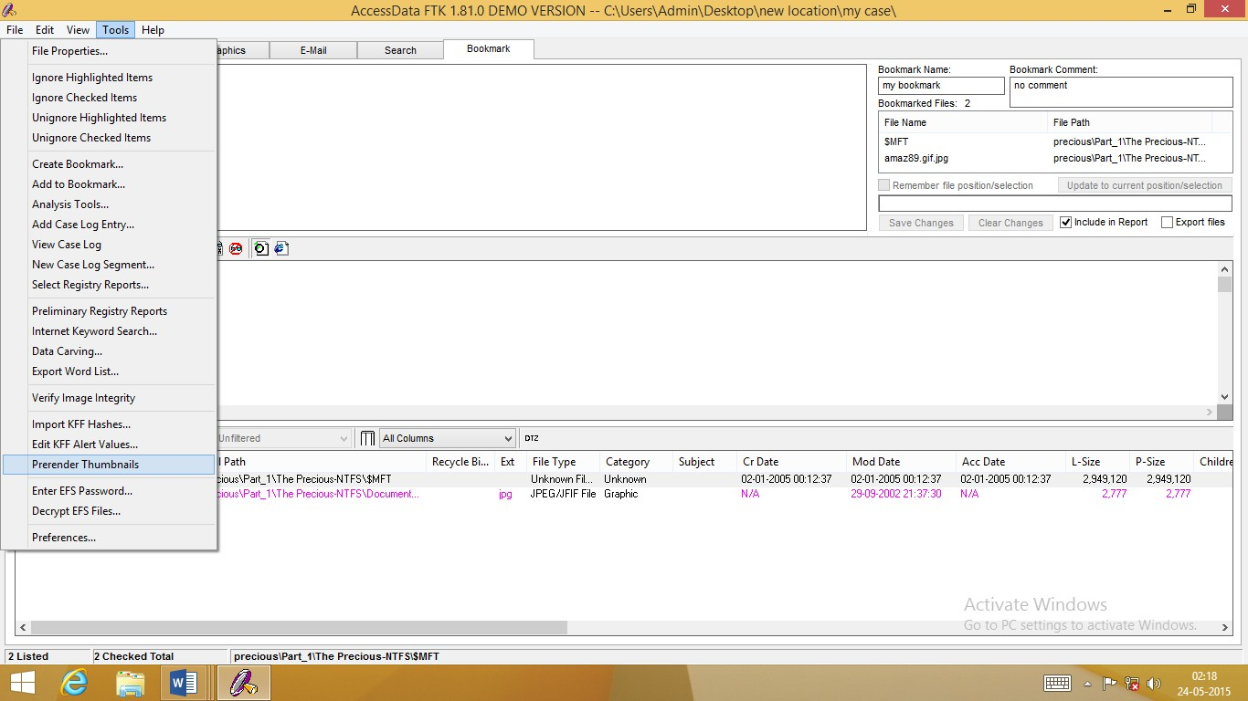
The Prerender Thumbnails Processing Files form lists each graphic as it is being processed and reflects the overall process status
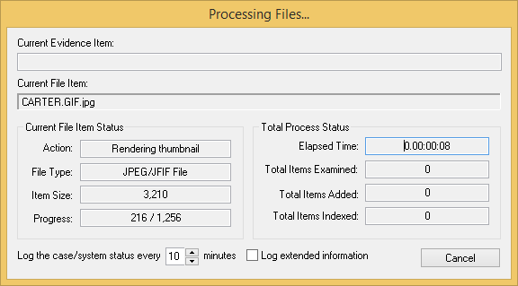
The Processing Files form also allows you to designate the interval at which you want the prerendering events logged to the case log. You can also choose to log extended information.
Note: The extended information includes information about file identification, indexing, hashing, and rendering graphic thumbnails for each evidence item.
Completing the processes may take some time, depending on the size of the evidence, the processor type, and the amount of available RAM.

Importing KFF Hashes
Using the Import KFF Hashes feature, you can import hashes from other databases or update the KFF database.

To import hashes to the KFF database:
- Click Tools, and then Import KFF Hashes.
- Browse to and select one of the following file types: AccessData Hash Database (.hdb) FTK Imager Hash List (.csv)
Hashkeeper Hash Set (.hke, hke.txt)
- Designate the hash set’s KFF Status as either Alert or Ignore.
- When finished, click OK.
The imported hash set is merged into the existing hash set and saved. Duplicate hashes are overwritten.
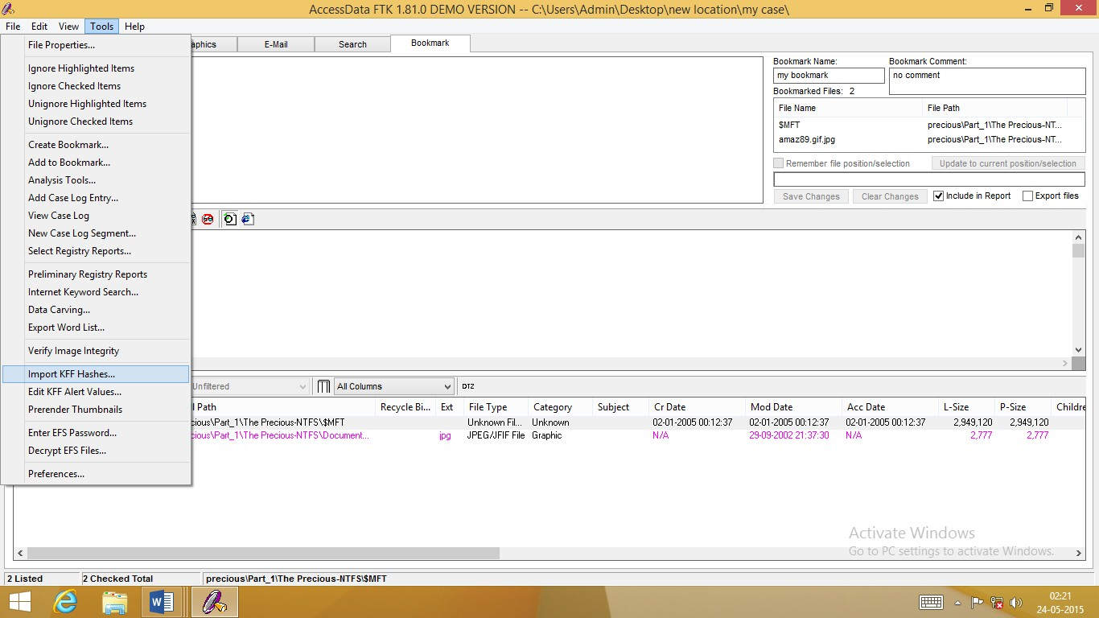

Verifying Image Integrity
To verify that an image has not changed:
- Select Tools, and then Verify Image Integrity. The Verify Image Integrity menu appears.
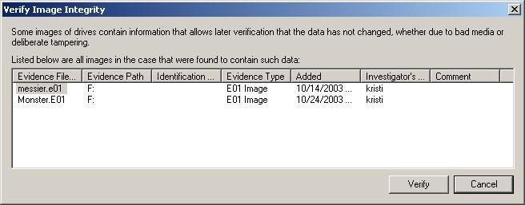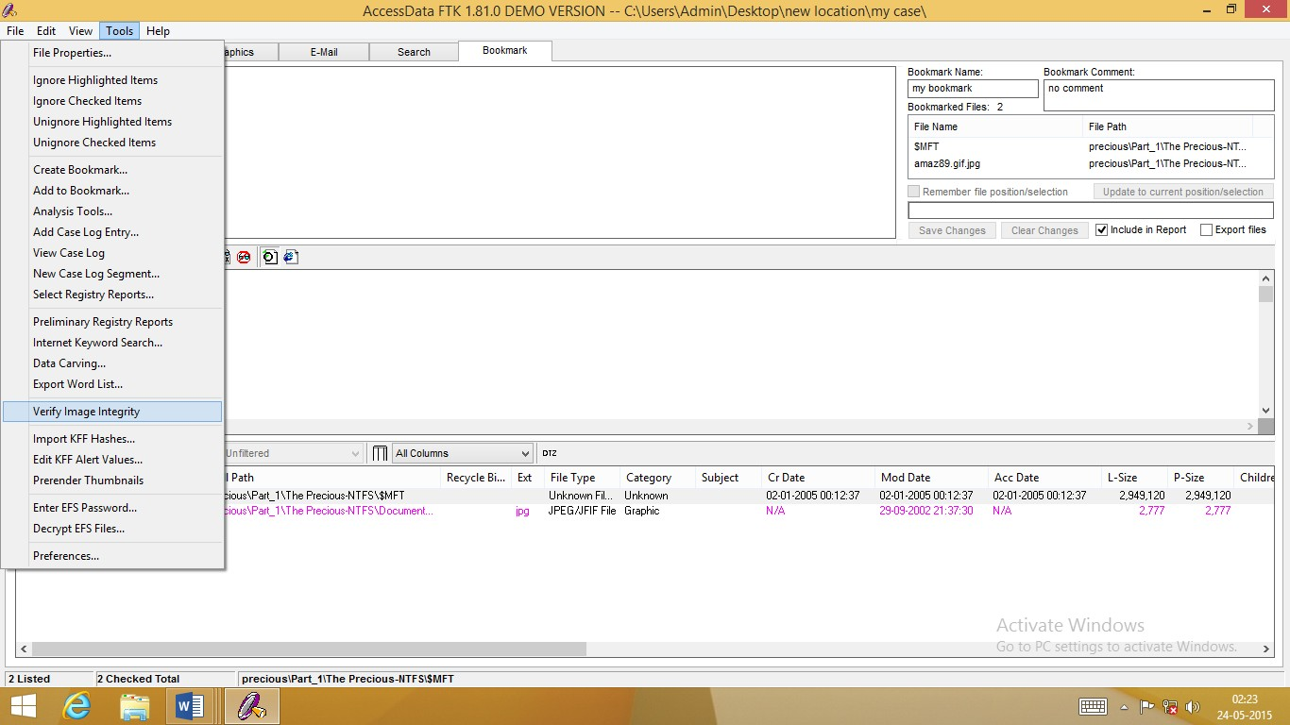

 | The Verify Image Integrity form contains the following
 | information:
Column | Description
Added | Date when image was added to the case.
Comment | Additional information entered about the image when it was added
 | to the case.
Evidence filename | The name of the image.

Column | Description
Evidence Path | The full path FTK uses to access the image file.
Evidence Type | The image format.
Identification | The evidence number that was entered when the image was added to
 | the case.
Investigator’s Name | The investigator assigned to the case.

- In the Evidence Filename column, select the image and click Verify.
- Click Yes to confirm.
The Processing Files form appears and displays the status of the verification.
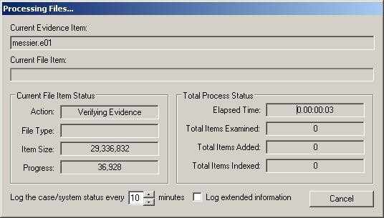
The Processing Files form reflects the overall process status. The Processing Files form also allows you to designate the interval at which you want the verification events logged to the case log. You can also choose to log extended information.
Note: The extended information includes information about file identification, indexing, and hashing.
Completing the processes may take some time, depending on the size of the evidence, the processor type, and the amount of available RAM

Using Analysis Tools
If any evidence item is added to the case without being fully analyzed, you can run analysis processes at a later time. The Analysis Tools form allows you to generate hashes, compare hashes to the KFF database, or index files.
To run these processes:
- Select Tools, and then Analysis Tools.
- Check the processes you want to perform.
- Select the files to process.
- Click OK.
The Processing Files form appears and displays the status of the processes

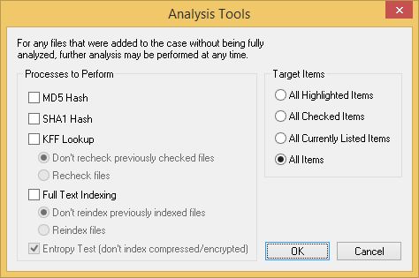

Using the Case Log

To view the case log:
Select Tools, and then View Case Log.
You can search for an event using the following options:
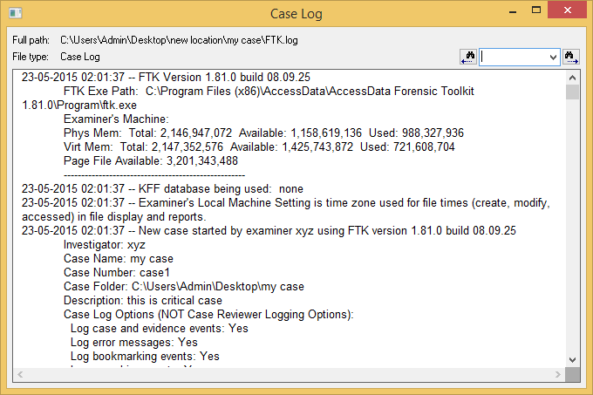
Adding Entries to the Case Log
During the case investigation and analysis, you can manually add information to the case log (ftk.log). You can add any information that you want included in the audit trail.
To add an entry to the case log:
- Select Tools, and then Add Case Log Entry.
- In the Investigator’s Name field, enter the name of the investigator or select the name from the drop-down list.
- In the Case Log Entry field, enter the information that you want to add.
- Click OK.
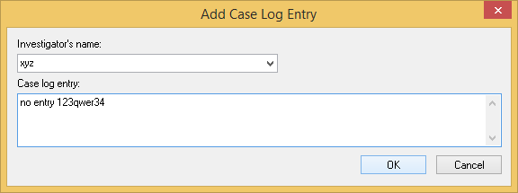

Copying Information from FTK

To copy file information:

- In the file list on any window, select the files that you want to copy information about.

- Select Edit, and then Copy Special.

- In the File Items to Copy list, select one of the following:
/..///////////////////////////////////////////////////////////////////////////////////////////////////// Item Description

All Checked Items All items checked in all file lists. You can check files in multiple lists.
All Currently Listed Items All items in the current file list.
All Highlighted Items All items highlighted in the current file list.
Items remain highlighted only as long as the same window
is
displayed.
All Items All items in the case.
//////////////////////////////////////////////////////////////////////////////////////////////////////////
- In the Load from Stored Column Settings drop-down list, elect the template that contains the file information that you want to copy.
- If you want to define a new column settings template:
5a Check or uncheck the Column Names, depending on which ones you want to include in the setting.
You can click Select All or Unselect All to mark or unmark all the columns.
5b To change the order in which the columns appear in the File List, select a column name and click Move Up or Move Down.
5c To create a new column setting, click Save As, enter a name in the field, and click OK.
- If you want to modify an existing template:
6a Click Columns.
6b Select the column setting you want to modify.
6c Modify the Column Settings form.
6d Click Save, and then Close.
- Under Copy Destination, select one of the following:
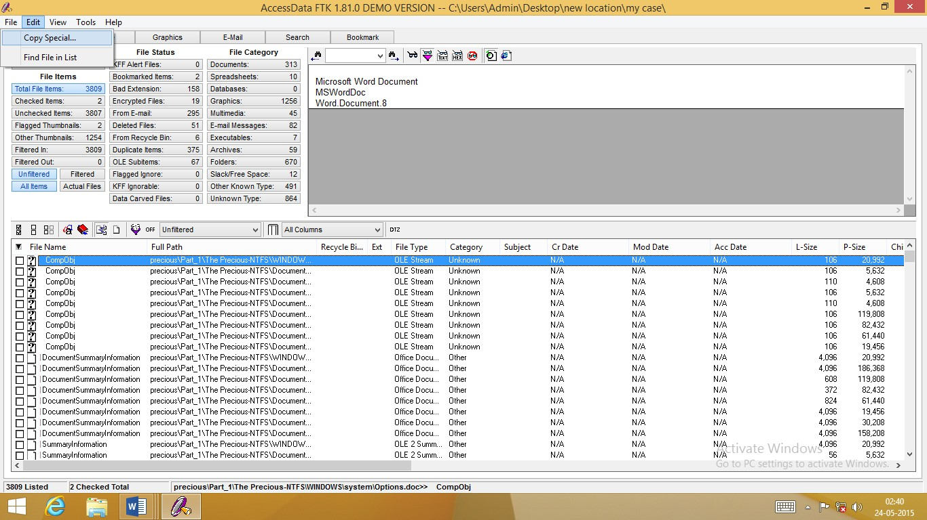
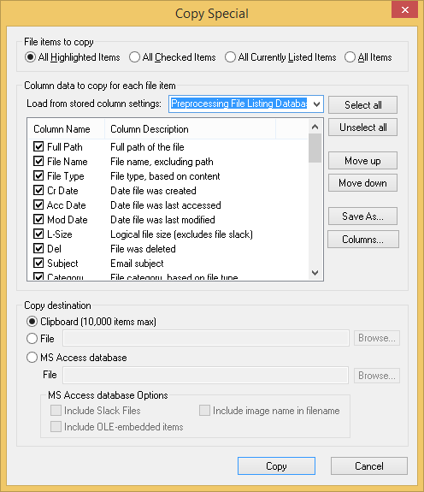

- Do one of the following:
For Clipboard and general File copies, click Copy.

Exporting Files
For MS Access Database copies, click Create Database.

- Select File, and then Export Files.
- Select the files to export.

Target Item | Description
All Checked Files | All items checked in all file lists. You can check files in multiple lists.
All Currently Listed Files | All items in the current file list.

Target Item | Description
All Files | All items in the case. All files includes parsed and extracted items
 | like the contents of a zip file, or the messages from an email archive,
 | or OLE streams that are part of Office docs, anything that didn't have
 | it's own entry in Windows Explorer.
All Highlighted Files | All items highlighted in the current file list. Items remain
 | highlighted only as long as the same window is displayed.

The filenames and paths are displayed.
- If you want to export e-mail attachments, check Include Email Attachments With Email Messages.
- In the Destination Path field, browse to and select the location where you want to export the files.
The default path is the \case_folder\Report\Export\ directory.
- If you want to add the archive name to the filename, check

Prepend Archive Name to filename.
- If you want to add the item number after the filename, check Append Item Number to filename to Guarantee Uniqueness.
- If you want to add an appropriate extension to a file that is missing an extension or has a bad extension, check Append Appropriate Extension to filename if Bad/Absent.
- To export the file in the same formatting as seen in the FTK program, check Export HTML View if Available. Some files may not be available in this view.
- To export files in which readable text is filtered out of binary files, check

Export Filtered Text View.
- Click OK.
To manually export files while maintaing the directory structure:
1 Select and highlight the files to export

- Right-click the files and then select Recursive File Export.
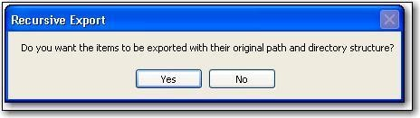
- Select the destination for these files. The Recursive Export dialog opens.

- If you want to include the path of the exported file, click
Yes.
The recursive path will include everything from image name down to the file or folder itself. If the path is too long, the file will still be dropped into the destination directory specified.
It will not truncate long file paths to make them fit. You will get a case log entry indicating that the file name was too long and the destination path was not created.
Recursive exported files have a Unique Item ID number appended to the filename to prevent them overwriting files with similar names.

About Recursive File Exporting
In versions of FTK before 1.80, the Recursive File Export function allows users to export a folder with all of its children and descendants. FTK 1.80 includes new functionality that allows users to also export upwardly or outwardly, rebuilding the original folder structure from the root of the image down to the selected file or folder, then exporting the descendants of the selected file or folder.
If the original path of the exported file is longer than that allowed by Windows, FTK will not be able to export it. In this case, FTK will notify the user and add an entry to the case log. This problem can often be avoided by exporting to a location near the root of the destination drive.

Exporting the Word List
If you are using PRTK, you can export the case index to use as a dictionary in the password recovery process.
To export the word list:
- Select Tools, and then Export Word List.
- Select the file and location that you want to write the word list to. The default filename is case_name.txt.
- To add registry files, click Add Files and then select the registry files to add to the word list.
This option is only available if you are using PRTK version 5.21a or later and you have Registry Viewer installed.
- Click Save.

Searching a Case

Conducting a Live Search

AccessData recommends live searching only if you do not have time to index the evidence. To perform a live search:
- In the Search window, click Live Search.
- In the Search Term field, enter the term you want to search for.
You can also enter a regular expression in this field if the Regular Expression box is checked. In the Item Type column, specify if you want FTK to search in Text or Hexadecimal
- Click Add to add the search term to the Search Items column. You can add as many terms as you want to the Search Items column. FTK searches for all terms listed in this column. After a term is added to the search list, you can click Edit Item to modify the term or Delete Item to remove the
term. Click Reset to clear the search list.
- In the Max Hits Per File field, enter the maximum number of times you want a search hit to be listed per file. The default is 200.
- Click Search.
Click the plus icon (+) next to a search line to expand the search results. Individual search results are listed in the search and file lists. To view a specific item, select the file in the search results or file lists. All search results are highlighted in the file.
If this search does not display the needed information, you can conduct several types of advanced searches..

Conducting an Indexed Search
The indexed search uses the index file to find the search term. Evidence items may be indexed when they are first added to the case or at a later time

In addition to performing searches within the case, you can also use the index as a dictionary for password recovery processes in the Password Recovery Toolkit (PRTK). You can export the index by selecting Tools, and then Export Word List.

All evidence should be indexed so that the index is accurate and complete. To index evidence when it is added to the case, check the Full Text Index box on the Evidence Processing Options form. To index evidence after it is added to the case, select Tools, then Analysis Tools, and then Full Text Indexing.

Single-Term Searches
To perform a single-term indexed search:
- In the Search window, click Indexed Search.
- In the Search Term field, enter the term you want to search for, including any wildcard characters.
As you type your search term in the field, the Indexed Words list scrolls to match the term. The Count column displays the number of times each indexed word is found in the case.
- Click Add to add the search term to the search list.
The Search Items column displays the number of hits and the number of files that contain the search term. When a term is added to the search list, you can click Edit Item to modify the term or Remove Item to remove the term.
- To refine the search, click Options.
- In the Search Items column, select the index term you want to search.
- Click View Item Results to initiate the search. The Filter Search Hits dialog appears.

 | 7 In the Filter Search Hits dialog, select one of the following:
Option | Description
All Files | Search all the files in the case. All files includes parsed and extracted
 | items like the contents of a zip file, or the messages from an email
 | archive, or OLE streams that are part of Office docs; anything that
 | didn't have it's own entry in Windows Explorer.
Checked Files | Search the checked files in the Explore, Graphics, E-Mail, or
 | Bookmark windows.
Don’t show this dialog | Disables the Filter Search Hits dialog for the current session. When
again this session | you restart FTK or load another case, the Filter Search Hits dialog
 | reappears.
 | If you want the Filter Search Hits dialog to reappear in the current
 | session, check Show Filter Search Hits Dialog for Each Session in the
 | Search Options dialog.
Filtered Files | Search files selected by a filter. Select the filter from the drop-down
 | list.

8 Click OK.

If FTK locates more than 200 kits, the Limit Search Hits dialog appears. You can limit the number of search hits that are highlighted per file.
9 Select the number of search hits to display per file. Check Apply to All to use your settings for all files.
When the single item search is complete, the query is added to the query list. (Each query is listed separately.)

Multi-Term Searches
To perform a multi-term indexed search:
- In the Search window, click Indexed Search.
- In the Search Term field, enter a term you want to search for, including any wildcard characters.

As you type your search term in the field, the Indexed Words list scrolls to match the term. The Count column displays the number of times the indexed word is found in the case.
- Click Add to add a search term to the search list.
The Search Items column lists the terms you have added to the search. It also displays the number of hits and the number of files that contain each search term as well as the cumulative results for all search terms.
After a term is added to the search list, you can click Edit Item to modify the term or Delete Item to remove the term.
- To refine the search, click Options.

- Define your search operators.
5a Click And to search for items containing all the terms.
5b Click Or to search for items containing any of the terms.
- Click View Cumulative Results to initiate the search. The Filter Search Hits dialog appears.
- Click OK

9 Select the number of search hits to display per file. Check Apply to All to use your settings for all files.
When the cumulative search is complete, the query is added to the search results list. (Each query is listed separately.)

Importing Search Terms

To import search terms:
- In the Search window, click Indexed Search.
- Click Import.
- Select the text file containing the search terms.
Important: The text file must only contain one search term per line. 4 Select Yes or No to display terms that have zero hits.
The terms are added to the search list

Viewing Search Results
When you complete either a single term search or a multi-term search, the results of each search appear as separate line items in the search results list.
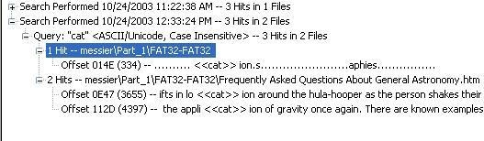

Click the plus icon (+) next to a search line to expand the search results. Individual search results are listed in the search and file lists.

To view a specific item, select the file in the search results or file lists. All search results are highlighted in the file.

Reloading a Search Query

To reload a query:

- Select the query in the search results list.

- Right-click and select Reload Search Query from the quick menu.
All the search terms for the selected query are added to the search list. You can reload multiple queries at a time
Wildcard Characters

 | dtSearch supports the following wildcard characters for
 | indexed searches:
Wildcard | Description
? | Matches any single character.
 | For example, “appl?” matches “apply” or “apple.”
 | Matches any number of characters.
 | For example, “appl” matches “application.”
~ | Matches words that contain the same root. This is called stemming.
 | For example, “apply~” matches “apply”, “applies”, and “applied.”
 | You can also select stemming by clicking Options and checking the
 | appropriate box.
% Matches words that have similar spellings. This is called a fuzzy search. For example, “ba%nana” matches “banana” and “bananna.”
You can also select a fuzzy search by clicking Options and checking the appropriate box.

# Matches words that sound the same. This is called a phonic search.
For example, “#smith” matches “smith” and “smythe.”
You can also select a phonic search by clicking Options and checking the appropriate box.

& Matches words that have similar meaning. This is called a synonym search.
For example, “fast&” matches “quick.”
You can also select a synonym search by clicking Options and checking the appropriate box.

~~ Matches a numeric range.
For example, “12~~24” matches “18.”
Indexed Search Options
When you are conducting an indexed search, you can use the Options menu to refine the search.
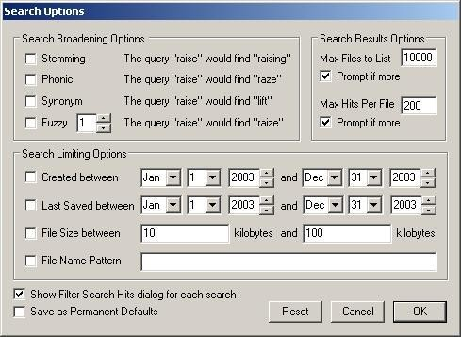
The following tables review the individual search options:

Search Broadening Options

Option | Description
Fuzzy | Words that have similar spellings, such as raise and raize.
 | Click the arrows to increase or decrease the number of letters in a
 | word that can be different from the original search term.
Phonic | Words that sound the same, such as raise and raze.
Stemming | Words that contain the same root, such as raise and raising.
Synonym | Words that have similar meanings, such as raise and lift.

Search Limiting Options

Option | Description
Created Between | Beginning and ending dates for the creation of a file.
 | 1. | Check the box.
 | 2. | In the date fields, enter the beginning and ending dates that you want to
 |  | search.

File Size Between Minimum and maximum file sizes, specified in KB.
  - Check the box.
  - In the size fields, enter the minimum and maximum size in KB of the files that you want to search.
Filename Pattern Limits the search to files that match the filename pattern.
The pattern can include “?” to match a single character or “*” to match zero or more characters.
For example, if you set the filename pattern to “?b”, only files whose second letter is “b” are searched.
To enter a filename pattern:
- Check the box.
- In the field, enter the filename pattern.

Last Saved Between Beginning and ending dates for the last time a file was saved.
1. Check the box.
In the date fields, enter the beginning and ending dates that you want to search

Search Results Options

Option | Description
Max Files To List | Maximum number of files that are listed in the results. The default is
 | 10,000 and the maximum is 32,767. (The results are displayed in the
 | search results list.)
 | You can change the maximum number in the field.
 | If you want to be prompted if there are more files than the specified
 | maximum, check the box.
Max Hits Per File | Maximum number of hits per file. The default is 200.
 | You can change the maximum number in the field.
 | If you want to be prompted if there are more hits than the specified
 | maximum, check the box.
Miscellaneous Options
Option | Description
Save as Permanent | Saves the current settings as your default search options. These
Defaults | options are applied to all searches.
Show Filter Search Hits | Displays the Filter Search Hits dialog every time you perform a
Dialog for Each Search | search. If this option is not selected, the default values are assumed
 | for every search.
 | This is the default option; however, if you check Don’t Show This
 | Dialog Again This Session in the Filter Search Hits dialog, the Filter
 | Search hits dialog does not appear again until you select this option
 | again. See page 158 for more information on the Filter Search Hits
 | dialog.

When you select any options on the Search Option dialog, the Search Options button turns red to indicate that non-default options are applied. If you save these selections as the new permanent defaults, the button returns to its original color.

Documenting Your Search Results
The following sections review the ways you can document the results of your Indexed and Live searches:

Copying Search Results to the Clipboard

When you right-click in the search results list, the quick menu displays the following options: Copy to Clipboard (including all hits)
Copy to Clipboard (visible information only)
Copy to Clipboard (including all hits) copies all the information for all the searches to the clipboard. This means that even if a search line is not expanded, the results of that search are copied to the clipboard.
Copy to Clipboard (visible information only) only copies the currently viewed information to the clipboard. This means that search results are not copied to the clipboard unless the search line is expanded.
After the information is copied to the clipboard, it can be pasted into a text editor or word processing program and saved. Then this information can be added to the case report as an supplementary file.

Using Copy Special to Document Search Results
The Copy Special feature allows you to copy specific information about files to the clipboard or a file.
To copy information about the files in your search results:
- In the search results list, highlight the search you want to document.
- Select Edit, and then Copy Special.
- In the File Items to Copy list, select All Highlighted Items.
- In the Load from Stored Column Settings drop-down list, select the template that contains the file information that you want to copy.
- If you want to define a new column settings template:
5a Check or uncheck the Column Names, depending on which ones you want to include in the setting.
You can click Select All or Unselect All to mark or unmark all the columns.
5b To change the order that the columns appear in the File List, select a column name and click Move Up or

Move Down.
5c To create a new column setting, click Save As, enter a name in the field, and click OK.
- If you want to modify an existing template:
6a Click Columns.
6b Select the column setting you want to modify.
6c Modify the Column Settings form.
6d Click Save, and then Close.

 | 7 Under Copy Destination, select one of the following:
Destination | Description
Clipboard | Copies the selected data to the Windows Clipboard where it can be
 | copied to another Windows application, such as an Excel spreadsheet.
 | The maximum number of evidence items that can be copied is 10,000.
File | Copies information to a file. The default filename is ftkfileinfo.txt.
 | Browse to and select the location for the information file.
MS Access Database | Creates an MS Access Database File based on the selected data.
 | Browse to and select the location for the database file, then select the
 | MS Access database Options including:

Include Slack Files
Include OLE-embedded items
Include image name in filename
8 Do one of the following:
For Clipboard and general File copies, click Copy. For
MS Access Database copies, click Create Database.

Bookmarking Search Results
To keep track of the files that were returned in a particular search, you can bookmark the search results. You can create a bookmark from the search results list or the file list.
To create a bookmark from the search results list:
1 Select the search you want to bookmark.
2 Right-click and select Bookmark Search Query Result from the quick menu

3 | In the Create New Bookmark form, enter the following:
Interface | Description
Apply Bookmark To | Displays the filename and path of the bookmarked file.
Bookmark Comment | Information you want to document about the bookmark.
Bookmark Name | The name of the bookmark.
Export Files | If checked, the files included in the bookmark are exported when a
 | report is generated.
Include In Report | If checked, includes the bookmark and its files in case reports.
Remember File | Remembers the highlighted text in the first bookmarked file, and
Position/Selection | automatically highlights it when you return to the bookmark. The
highlighted text also prints in the report.
This option is available only if the first file in a bookmark is selected.
4 | Click OK.
To create a bookmark from the file list:
1 | Select the files you want to include in the bookmark.
2 | Click the bookmark icon | or right-click and select
Create Bookmark from the quick menu.
3 | In the Create New Bookmark form, enter the following:
Interface | Description
Apply Bookmark To | Displays the filename and path of the bookmarked file.
Bookmark Comment | Information you want to document about the bookmark.
Bookmark Name | The name of the bookmark.

Export Files | If checked, the files included in the bookmark are exported when a
 | report is generated.
Include In Report | If checked, includes the bookmark and its files in case reports.

Interface | Description
Remember File | Remembers the highlighted text in the bookmarked file and
Position/Selection | automatically highlights it when you return to the bookmark. The
 | highlighted text also prints in the report.
 | This option is available only if the first file in a bookmark is selected.
 | 4 Click OK.
 | The bookmark now appears in the Bookmark window.

